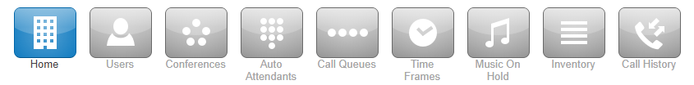
Office Manager User Guide
[Company name] version 1.0.1
Contents
1 Intro 5
2 The Manager Portal 7
2.1 Accessing the Manager Portal 7
2.2 Logging in 7
2.3 Homepage Layout 8
2.3.1 Call Graph 9
2.3.2 Peak Active Calls 9
2.3.3 Call Volume 9
2.3.4 Total Minutes 9
2.3.5 Current Active Calls 10
2.4 The Attendant Console 11
2.4.1 Contacts 11
2.4.2 Call Queues 12
2.4.3 Auto Attendants 12
2.4.4 Make Call 12
3 Account Levels 12
3.1 Organization / Domain Level 12
3.2 Account Level 12
4 Your Account Level 13
4.1 Account Homepage Layout 13
4.2 Profile 14
4.2.1 Directory Options 14
4.2.2 Caller ID Information 14
4.2.3 Change Account Security 15
4.3 Account Level Navigation Options 16
4.3.1 New Voicemail Messages Panel 16
4.3.2 Active Answering Rule Panel 17
4.3.3 Active Phones Panel 17
4.3.4 Recent Call History Panel 17
4.4 Messages 18
4.4.1 Voicemails 18
4.4.2 Call to Play 19
4.4.3 Forward Voicemail 19
4.4.4 Download Voicemail 19
4.4.5 Save 19
4.4.6 Delete 19
4.5 Chat 20
4.6 Settings 20
4.6.1 Enable / Disable Voicemail 20
4.6.2 Inbox Options 21
4.6.3 Greetings 21
4.6.4 Unified Messaging 23
4.6.5 Save 23
4.7 Contacts 23
4.7.1 Groups 24
4.8 Answering Rules 25
4.8.1 Ring Time Out 25
4.8.2 Allow and Block Phone numbers 26
4.8.3 Add Rule 26
4.8.4 Answering Rule configuration example 31
4.9 Your Time Frames 33
4.9.1 Adding Time Frames 34
4.10 Phones 36
4.11 Music on Hold 37
4.11.1 Music on Hold Settings 38
4.11.2 Add Music on Hold to your account 38
4.12 Your Account Call History 38
4.12.1 Call History Filters 39
4.12.2 Caller Number 39
4.12.3 Dialed Number 39
4.12.4 Call Type 40
4.13 Exporting Call History 41
4.14 Log Out 41
5 Organization Level 41
5.1 Usage Statistics 41
5.2 Application Menu 42
5.3 Users 42
5.3.1 Bulk Import Users 43
5.3.2 Creating a New User 43
5.3.3 Scopes 43
5.3.4 Add Phone Extension 44
5.3.5 User Options 44
5.3.6 Hide System Users 44
5.4 Conference 45
5.4.1 Creating a new Conference Bridge 45
5.4.2 Dedicated Conference Bridge 45
5.4.3 Owned Conference Bridge 45
5.4.4 Direct Phone Dial 45
5.4.5 Leader PIN 46
5.4.6 Participant PIN 47
5.4.7 Minimum Participants to Start 47
5.4.8 Conference User Experience Options 47
5.4.9 Require a Leader 47
5.4.10 Prompt all participants for their name 47
5.4.11 Announce participant arrivals/departures 48
5.4.12 Conference Bridge Reports 48
5.4.13 Edit Conference Bridge 48
5.4.14 Delete Conference Bridge 48
5.5 Auto Attendants 48
5.5.1 Creating a new Auto Attendant 49
5.5.2 Intro Greeting 49
5.5.3 Menu Prompt 50
5.5.4 Dial Pad Menu 50
5.5.4.1 User 51
5.5.5 Options 53
5.5.5.1 Enable Dial by Extension 54
5.5.5.2 If no key is pressed 54
5.5.5.3 If unassigned key is pressed 54
5.6 Call Queues 54
5.6.1 Add Call Queue 54
5.6.2 Basic Tab 55
5.6.3 Pre Queue Options tab 57
5.6.4 In Queue Options 58
5.6.5 Managing Call Queue 60
5.6.6 Edit Agents 60
5.6.7 Edit MoH (Music on Hold) 62
5.6.8 Edit Queue 63
5.6.9 Delete Queue 63
5.7 Music on Hold 63
5.7.1 Adding Music on Hold to organization 64
5.7.2 Reprioritizing Music on Hold playing order 64
5.7.3 Music on Hold Settings 64
5.7.4 Enable Music on Hold 64
5.7.5 Randomize Music on Hold 65
5.7.6 Play introductory greeting 65
5.8 Inventory 65
5.8.1 Phone Numbers tab 65
5.8.2 Enable Time Frame 67
5.8.3 Caller ID Prefix 68
5.8.4 Notes 68
5.8.5 Filter 68
5.8.6 Export 69
5.8.7 SMS Numbers tab 69
5.8.8 Phone Hardware tab 70
5.8.9 Add Phone 70
5.8.10 Advanced tab 71
5.8.11 Export 71
5.8.12 SNAPbuilder 71
5.9 Call History 72
5.9.1 Filter 73
5.9.2 Export Call History 73
5.9.3 Monthly 74
5.9.4 Weekly 74
5.9.5 Daily 74
5.9.6 Custom 74
5.9.7 Allow run this export immediately 74
5.9.8 Email Notification 74
5.9.9 Options tab 74

Intro

Welcome to Office Manager onboarding training. In this training, we are going to teach you all about the different configuration options available to you as an office manager so you can manage your organization and route calls.

We will discuss Users- How to create them, configuring the user's options, and managing existing users.

How to create conference bridges and the difference between Dedicated and Owned Conferences.

We will go over the Auto Attendant options and review the dial pad menu options.

Your account type also has the ability to configure new call queues and manage existing ones.

You will be able to create shared Time Frames with others in the domain and will be able to apply to their answering rules.

We will teach you how to customize the Music on Hold for your Domain.
How to route phone numbers to a destination using the inventory.

And the Call History which displays the call activity on your domain.

The Manager Portal
The Manager Portal is a web interface that you will use in order to manage your organization, manage your account, and communicate with others.

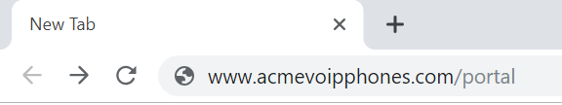
Accessing the Manager Portal

In order to access the manager portal, open a web browser and enter your fully qualified domain provided by your administrator into your web browser as seen in figure 2.1. After entering the domain into your browser, you will be taken to the login page as seen in figure 2.2
2.1

Logging in
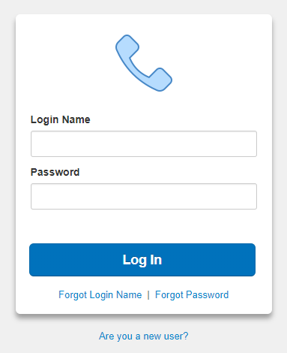
On the login page enter your credentials provided by your administrator or click the New User link.
2.2

If you click the New User link a new window appear asking for your Email address and Extension number (extension number is optional and not required to be entered as seen in figure 2.2.
Then enter your email and extension number and your credentials will be emailed to you.
Once you’ve entered our credentials you will be taken to the Manager Portal homepage as seen in figure 2.3. There are 2 levels to the manager portal for you as an Office Manager the Manage Organization level and your account level. When you login you are taken to the Organization level as seen in figure 2.3.

Homepage Layout
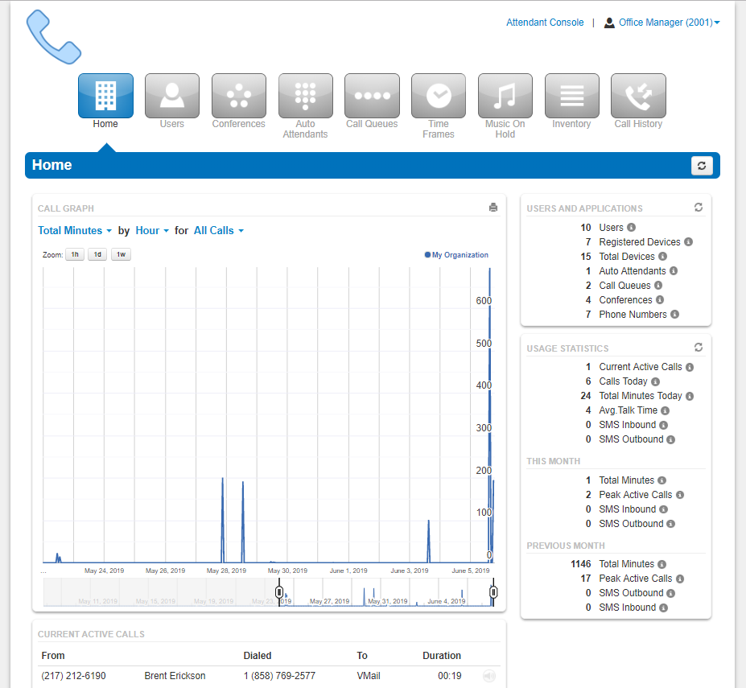
The Homepage consist of your application selection at the top and widgets that display information regarding the domains activity as seen in figure 2.3 below.
Figure 2.3

Call Graph
The Call Graph widget as seen in figure 2.3.1 gives a visual representation the Call Graph allows you to visually graph the number of calls by:
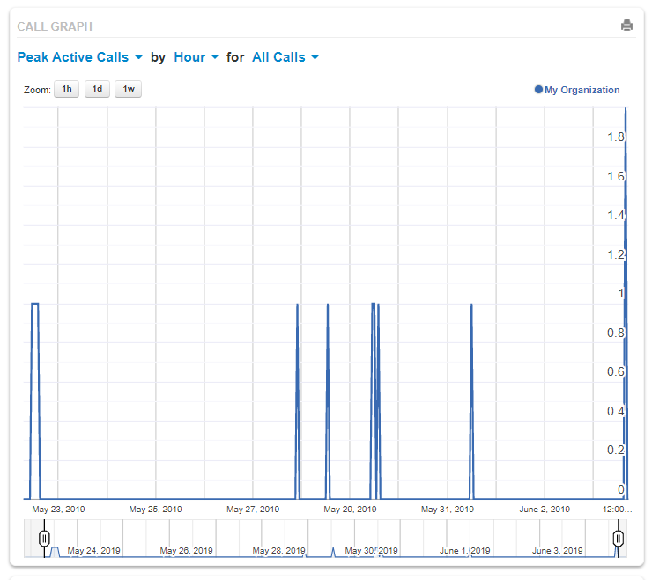
2.3.1

Peak Active Calls
The number of concurrent calls places at one time.

Call Volume
Includes answered calls, abandoned calls, forwards, and voicemail.

Total Minutes
Total minutes shows the total number of minutes your organization has used.

Current Active Calls

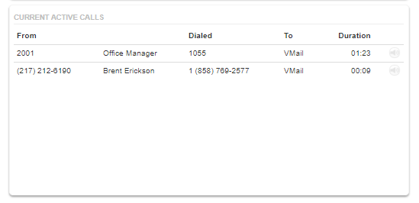
The Current Active Call widget as seen in figure 2.3.5 displays all current calls your organization currently has connected. Displayed with the caller ID phone number and name of the person placing the call. The number they dialed. The application the call is being sent to such as user, Auto Attendant, voicemail, etc. Followed by the duration of the connected call. The speaker icon as seen in figure 2.3.5.a to the right of the call will allow you to monitor the call.
2.3.5
2.3.5.a

Cal Monitoring
2.3.5.1
When clicking on the speaker icon will display the Audio Monitoring widget as seen in figure 2.3.5.1 which will allow you to select from the following audio monitoring options.

Join Call
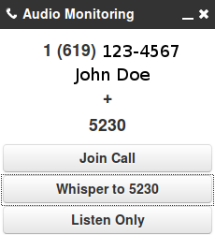
Will Allow you to join the call so you can speak to all parties on the line.

Whisper to
This option allows you to speak only to the user’s extension that is on the call. The person on the other side of the call will not be able to hear you.

Listen Only
Listen only allows you to listen or monitor the call without anyone being able to hear you.

The Attendant Console
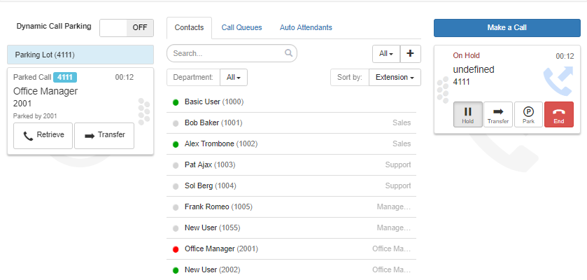
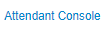
Above the Usage Statistics widget in the top righthand corner is a link to the Attendant Console link as seen if figure 2.4. Clicking the Attendant Console link will open another webpage and take you to the Attendant Console Contact’s page which will display the domain’s Contacts and Parking Lots as seen in figure 2.4.a.
2.4.a
2.4

Contacts
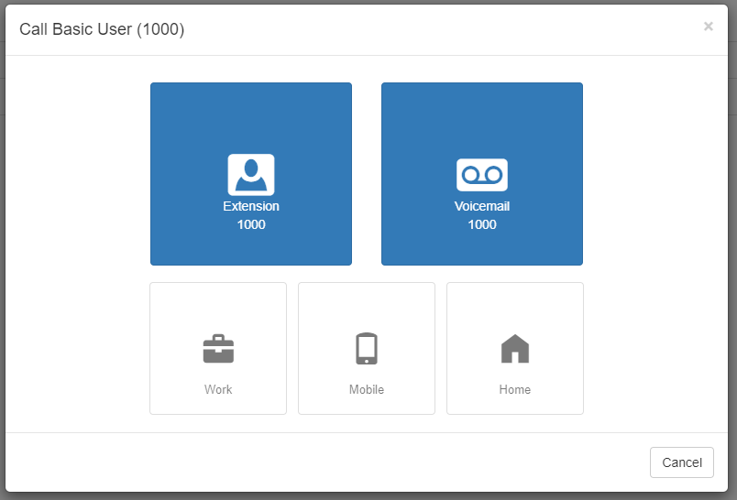
The contacts tab provides you an overview of all the contacts in your organization and provides a status indicator.
2.4.1
A green circle displayed next to a user’s name and extension means that user is currently available. A red circle means the user is currently unavailable as they are already on the phone with another user or set their status to Do Not Disturb.
Clicking on an extension will bring up a new window as seen in figure 2.4.1, where you can call the contact at their extension, their work contact, mobile number, or their home contact number. You can also leave a voicemail for the contact as well.

Call Queues
The Call Queues tab will give you an overview of how many Call Queues your organization has, and the number of agents logged into each queue.
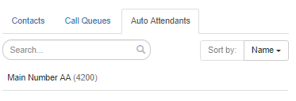
2.4.3

Auto Attendants
The Auto Attendants tab allows you to see an overview of the Auto Attendants your organization has configured as seen in figure 2.4.3.

Make Call
2.4.4

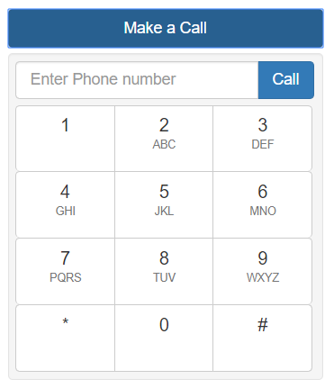
The Make a Call button as seen in figure 2.4.4 will open a dial pad menu as seen in figure 2.4.4.a and allow you to enter a destination to call. Once you enter a phone number or extension and click call a call is generated and sent to your devices. When you answer the call the called party is called and the call is connected.
Next to the Attendant Console link you will see your extension number and name. When clicking on your extension you will see the option to manage your account or check messages as seen in figure 3.6.

Account Levels
3.6
As an office manager your account has 2 levels, the Organization level and your account level.
2.4.4.a

Organization / Domain Level
This is where you are taken after you login to the manager portal. This level is where you can make changes and see overview for the entire organization.

Account Level
The My Account level will allow you to manage your extension settings and see your specific Call History, Music on Hold, and set your answering rules as seen in figure 4.

Your Account Level
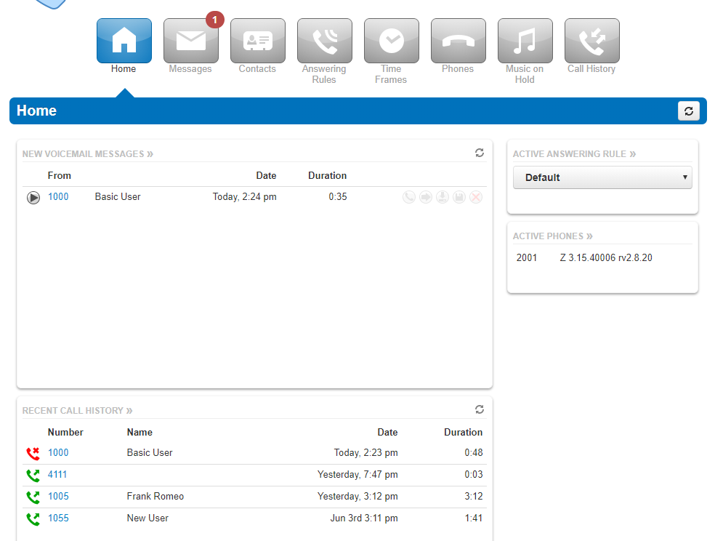
4

Account Homepage Layout
Your account level is where you can make changes to your own personal account and manage your settings. On the homepage you will see an overview of new messages, recent Call History. The homepage will also display which rule is active and what phones are currently registered to your account.
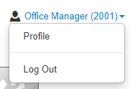

In the top righthand corner of the Manager Portal you will see the links for the Manage Organization as seen in figure 4.a. which takes you back to the organization level of the manager portal.
The Attendant Console will open the Attendant Console window.
Clicking on your name and extension number on the Account level
4.b
4.a
will display the options to edit your Profile information and log out of the manager portal as seen in figure 4.b.

Profile
The Profile options allows for you to change your account options such as your first or last name, and Time Zone as seen in figure 4.2.

Directory Options
The directory options allow you to configure

Announce in Audio Directory
Checking the Announce in Audio Directory will list you in the company directory. Callers will be able to search for your extension when routed to a company directory.

List in Directory
The List in Directory options controls if your extension is listed in the Contacts in the Manager Portal.

Caller ID Information
The Caller ID Information section allows you edit your area code that will be in your Caller ID and appended when only dialing 7 digits on outbound calls. You cannot edit your Caller ID or 911 Caller ID. If you need that changed contact your officer manager.

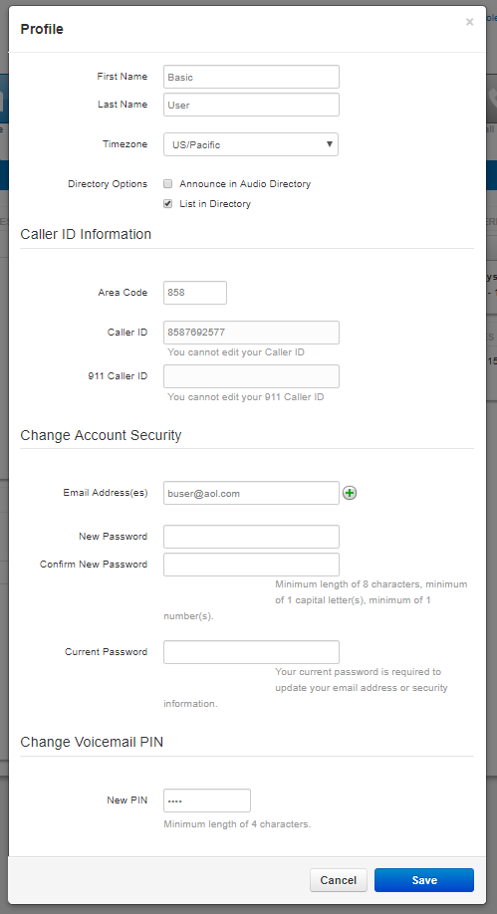
Change Account Security
Figure 4.2
The Change Account Security section in the profile windows allows you to manage your passwords and email settings for your account.

Email Address
The Email Address field is the is where you configure your email address you would like to receive notification from. You can add more than 1 email address by clicking the green plus sign next to the email address field.

New Password
The Password field allows you to configure your account with a new Manager Portal password used to login with. Below is the Confirm Password field which requires you to enter the new password a second time for verification.

Current Password
The Current Password field is required to be filled out with your current password if any changes are made to any of the Change Account Security options.

Change PIN
The Change PIN option allows you to change the numeric password used to check voicemail messages over the phone.
Below the Manage Organization, Attendant Console and your profile and logout the application navigation options are displayed as seen in figure 4.2.

Account Level Navigation Options
On the top of the home page under the Attendant Console, Profile, and Log Out options is the application navigation menu as seen in figure 4.2. Selecting an option here will take you to that applications management center.
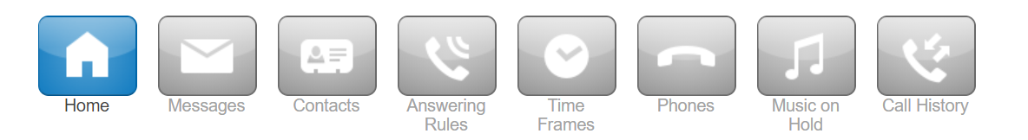
4.2

New Voicemail Messages Panel
The New Voicemal Messages panel displays all new voicemails as seen in figure 4.3.1. The voicemails are displayed with the number of the caller that left a voicemail. Their Caller ID name. Followed by the date and time the message was left and the duration of the voicemail.
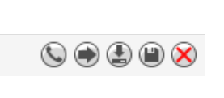
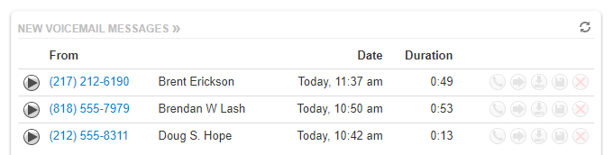
You will also see the options to Call to Play, forward the voicemail, download the voicemail locally to your computer or delete the voicemail message as seen in figure 4.3.1.a.
Figure 4.3.1.a
Figure 4.3.1
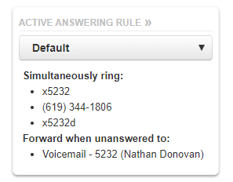
4.3.2

Active Answering Rule Panel
To the right you will see the Active Answering Rule window which will display which rule is currently active and provide a summary of how calls are routed when they reach your extension as seen in figure 4.3.2. You can select a different answering rule by clicking the Active Answering Rule drop down and selecting a different rule.

Active Phones Panel
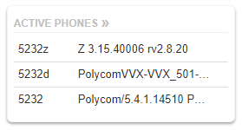
The Active Phone fields below list the active phones currently registered to your account you can send and receive calls from as seen in figure 4.3.3. If you do not see a device listed there that should be, that means the device is not configured for your account or the device is currently unregistered. Make sure the device is plugged in, or if using a softphone make sure the softphone program is running.
4.3.3

Recent Call History Panel
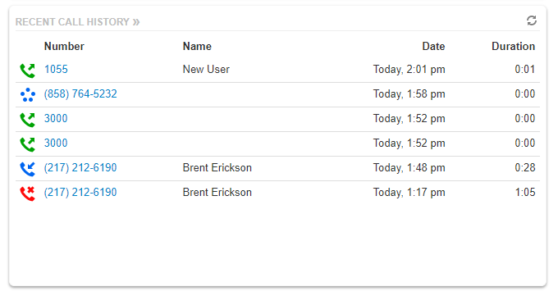
The Recent Call History panel provides an overview of the last 10 calls as seen in figure 4.3.4.
4.3.4
A phone icon with a green arrow represents an outbound call. A phone with a red icon means a call was not answered. Phone icon with a blue arrow means an inbound call was answered. 5 blue circles mean that a call was placed to a conference bridge.


Messages
The Messages icon on your account level as seen in figure 4.4 is where all your voicemails, chat messages, and account settings for voicemail options are stored.
4.45

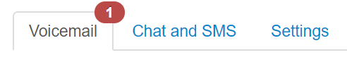
Voicemails
4.4.1
Clicking the Message Center will take you to the voicemail tab. On the top of the tab, you will see a new message indicator showing how many (if any) new voicemails your account has as seen in figure 4.4.1.
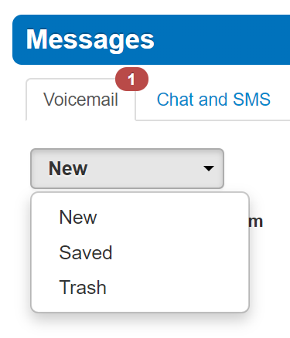
4.4.1.a
Underneath the tab selection you will see a drop down as seen in figure 4.4.1.a to display new voicemails, saved messages, or trashed messages.
On the new page you can see all your new voicemail messages displayed with the caller’s phone number. The Caller ID name, along with the date, time, and duration of the message as seen in figure 4.4.1.b.
To the right of the message and message information you will see the voicemail management options as seen in figure 4.4.2.
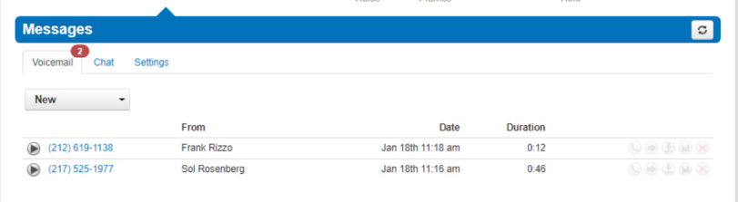
4.4.1.b


Call to Play
Figure 4.4.2
Is the phone icon in figure 4.4.2 and allows you to use the Call to Play options where the system will call your extension and play the voicemail.

Forward Voicemail
The arrow pointing to the right in figure 4.4.2 allows you to forward the voicemail to another extension.

Download Voicemail
The Arrow pointing down as seen in figure 4.4.2 allows you to download the voicemail to your computer.

Save
The disk icon as seen in figure 4.4.2 allows you to save the voicemail in your account Saved section and will appear when selecting the Saved option from the voicemail box options as seen in figure 4.5.

Delete
The red X as seen in figure 4.4.2 is the delete option and clicking the icon will remove the voicemail. Once a voicemail has been deleted it cannot be recovered from the phone system. If your account is configured to send an email notification with voicemail attachment

Chat
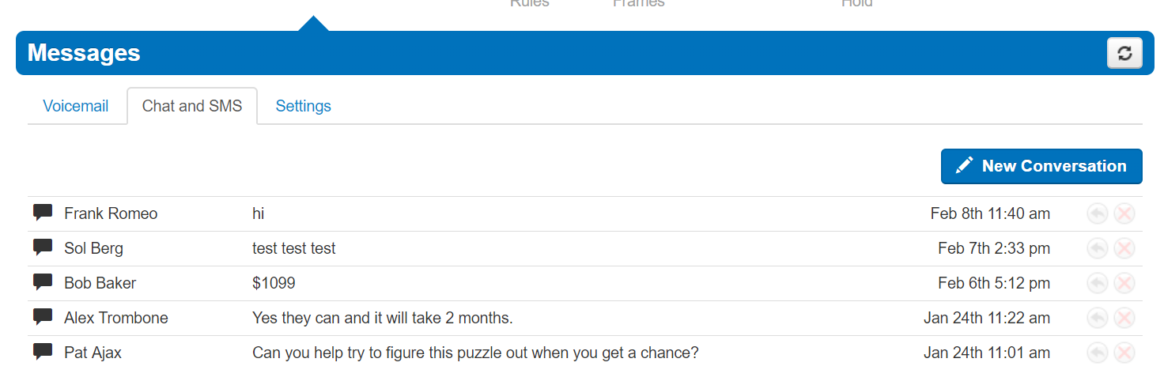
On the Chat tab you can see all your Chat conversations as seen in figure 4.5. The message is displayed with the contacts name. The last message received or sent.
4.5
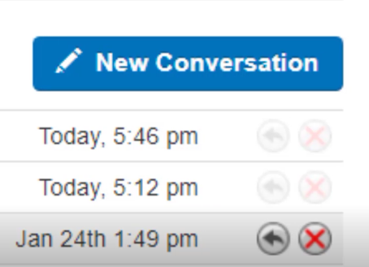
Figure 3.4.a
To the right of the message you will see the time and date that message was sent or received as seen in figure 4.5. Along with the option to reply to the message. Or delete the message. To start chatting with someone, click the
4.5..a
New Conversation button as seen in figure 4.5.a.
Start typing the contacts name or press down arrow on your keyboard to list all contacts you can chat with.
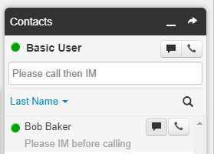
You can also chat by clicking the Contacts icon, then clicking the chat icon next to their name as seen in figure 4.5.b. Or by finding the person in the contacts window and selecting the message icon next to their name.
4.5.b

Settings
Next is the settings tab as seen in figure 4.6. This is where you can make changes to how your account handles voicemail.

Enable / Disable Voicemail
The Enable voicemail option as seen in figure 4.6 allows you to enable or disable the voicemail by clicking the checkbox next to Enable Voicemail. A check means voicemail is enabled and unchecked means that it has been disabled.
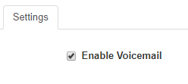
4.6

Inbox Options
Below the option to enable and disable are the voicemail Inbox Options as seen in figure 4.6.2. These allow you to control your experience when calling in and checking your voicemail.

Sort voicemail inbox by latest first
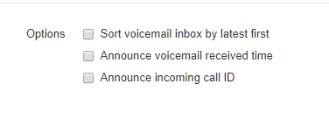
Clicking the box next to Voicemail inbox by latest first will configure your voicemail to play the voicemail message that was last left first. If this option is not enabled the voicemails will be played in the order they were received.
4.6.2

Announce voicemail received time
Clicking the box next to Announce voicemail received time will tell you the time the voicemail was left when checking messages.

Announce incoming call ID
Clicking the box next to Announce incoming Call ID will have your voicemail read the caller ID number off.

Greetings
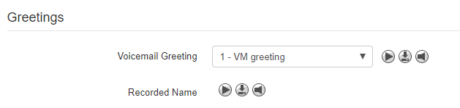
Under the voicemail inbox options, you will see the Greetings section as seen in figure 4.6.3 which contains your Voicemail greeting and recorded name used in the company directory.
4.6.3


Manage Voicemail Greetings
4.6.3.1
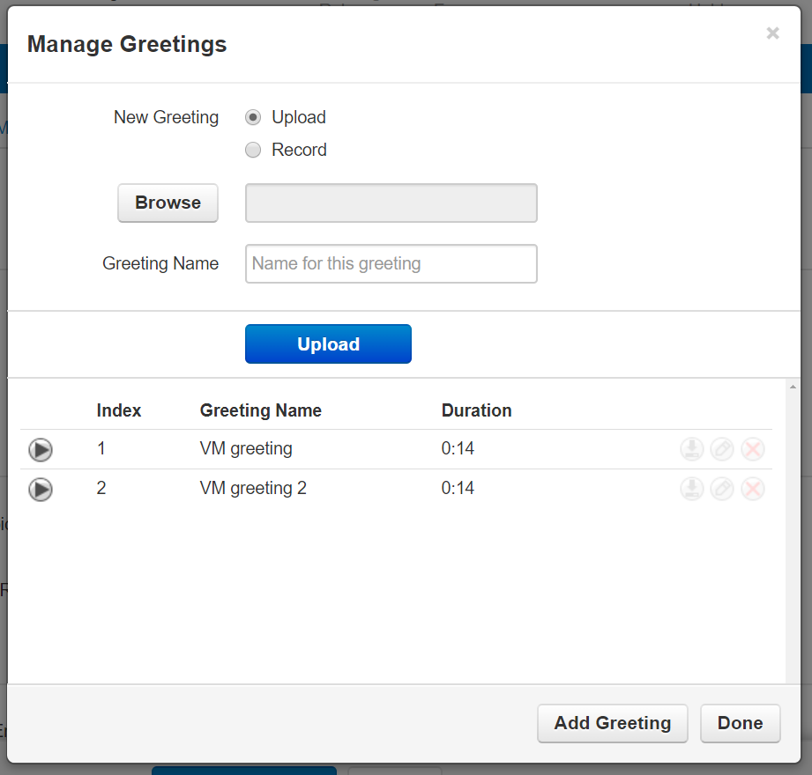
Clicking the manage icon as seen in figure 4.6.3.1 will take you to the manage greeting page as seen in figure 4.6.3.1.a selecting the Upload option will allow you to upload a new voicemail greeting by selecting a file from our computer.
Selecting the Record options allows you to record a greeting by calling you at a local extension or full phone number. Then clicking the call button. The system will then call you at the number entered and you will be able to record your greeting. You can record multiple greetings. After they have been uploaded you can Download them, Edit them, or Delete them.
4.6.3.1.a
Under the Greetings you will see the Unified Messaging options which will allow you to manage your email notifications. If you would like to receive email notifications, change the option from none to the email notification setting you would like. Send with hyperlink, will send your email with a hyperlink to the voicemail.
4.6.3.2

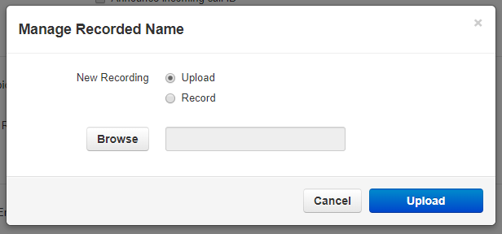
Recorded Name
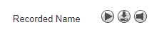
The Recorded Name option as seen in figure 4.6.3.2 allows you to record your name which will be played when the company directory says your name. If no recording is uploaded the system will read your name off by each letter. When clicking the Manage icon the Manage Recorded Name window appears as seen in figure 4.3.6.2.a which will allow you to upload a recording from your computer. Or record a new name by clicking the record and having the system call you to record.
4.3.6.2.a

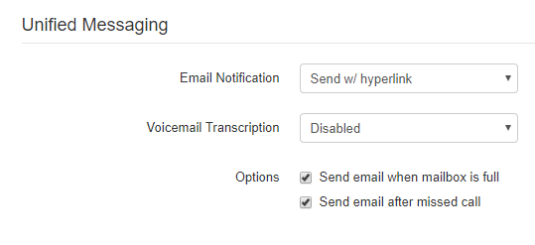
Unified Messaging
The Unified Messaging center as seen in figure 4.6.4 allows you to control your email notifications for voicemails and missed calls.

Email Notification
The Email Notification options as seen in 4.6.4.1 allows you to select if you would like to receive an email notification when a voicemail is left and what to do with the voicemail if an email notification is sent.

Voicemail Transcription
4.6.4.1
The Voicemail Transcription option allows you to select if you want voicemail transcription enabled, a service that translates a voicemail message into text, and which service provider you would like to use for transcription if any are available.

Send email when mailbox is full
The Send email when mailbox is full option will send you an email when you’ve gone over your mailbox data storage limit.

Send email after missed call
Enabling the Send email after missed call will email you each time you miss a call even if the caller does not leave a voicemail.


Save
4.6.5
For any of the changes to take effect you must click the Save button at the bottom of the page as seen in figure 4.6.5. The Cancel button will disregard any changes made.
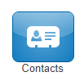

Contacts
The Contacts center icon as seen in figure 4.7 is where all users with “List in Directory” enabled under their profile as seen in figure 4.7.a are listed. If you do not see a user listed that is because “List in Directory” has been disabled.
4.7
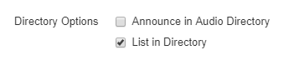
4.7.a

Groups
On the Contacts page, you will see a drop down as seen in figure 4.7.1.a that will let you filter for:

All Users
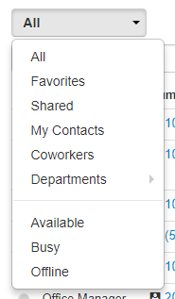
Displays all users on the system with List in Directory enabled.

Your Favorites
Displays contacts you selected as favorites. Which you can add to by clicking the star next to the contacts name.

Shared
Shared contacts are contacts available to the entire organization added by Office Managers.

My Contacts
Contacts you have manually added by clicking the Add Contact button in the top right.

Coworkers
Displays all contacts in organization with List in Directory enabled.
4.7.1

Departments
Which break users down by the Department entered on their user profile.

Available Users
Displays contacts that are available to be called or chat via the portal.

Busy Users
Are users currently on the phone or has their status set to Do Not Disturb.

Offline Users
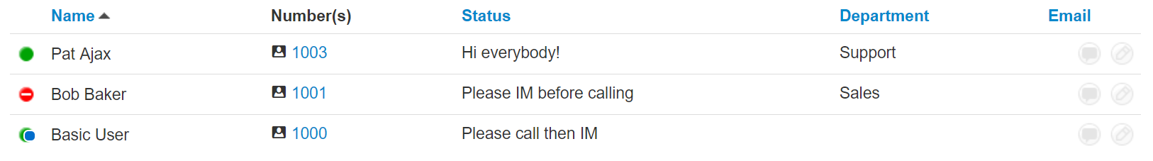
Users who do not have a registered device and not logged into the portal available to chat.
4.7.b

When selecting a contacts group option, the contacts for that group will appear as seen in figure 4.7.b you will see the contacts listed. You can sort them by Name, Status, Department and Email. Contacts displayed with a green dot are available. Contacts displayed with a smaller blue dot in front of the green means that person is available to chat in the portal. If the contact has a red circle that means the user is currently busy.
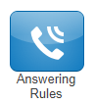

Answering Rules
The Answering Rules icon as seen in figure 4.8 will take you to your answering rules center. Answering Rules are how you control what devices ring, how long those devices ring for, and what to do with the call if it is not answered.
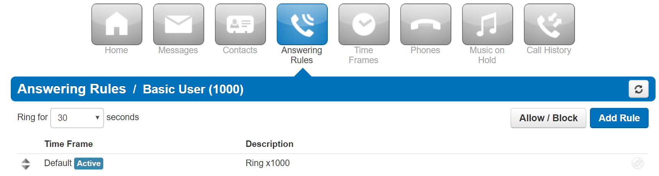
4.8
4.8.a

Clicking the Answering Rules icon in will take you to your Answering Rules center as seen in figure 4.8.a. Here you will see your answering rules listed. If you

Ring Time Out
4.8.1
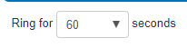
When you click on Answering Rules you will see the option to set the Ring Time Out as seen in figure 4.8.1. This is what controls how long a call attempts to ring you for.
To set the ring time out click the drop down to select how many seconds you would like calls to ring before sending the call to your Voicemail. If you do not want a ring time out, meaning you want your phone to ring forever, select Unlimited at the bottom of the drop down.

Allow and Block Phone numbers
4.8.2
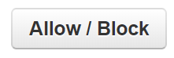
To the right you will see the Allow and Block button as seen in figure 4.8.2. This allows you to enter certain phone numbers to allow or prevent them reaching you. Clicking the Allow / Block button will open the Allow / Block window as seen in figure 4.8.2.a
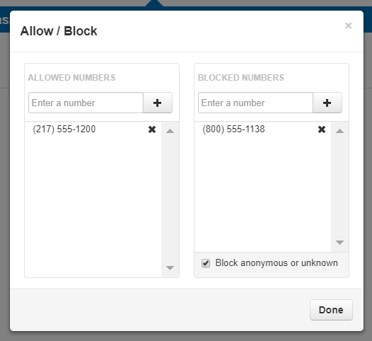
On the left is the allowed numbers. This allows you to add numbers that are blocked by the domain so you can still receive calls from that user.
4.8.2.a

Phone numbers added to allow will also let the call bypass Call Screening. If you have Call Screening enabled but want certain phone numbers to not have to record their name when calling you, add them to the allow field. Then when that number calls you, they will be sent directly to you and not have to record their name first.
Block allows you to add phone numbers you do not want to be able to reach you. To add a phone number to Allow or Block, simply enter the number into the respective field and click the plus sign to add the phone number. You can also block all anonymous or unknown callers simply by clicking the check box next to Block anonymous or unknown.
Click Done once you have finished adding phone numbers.
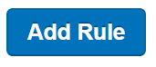

Add Rule
To the right is the Add Rule button as seen in figure 4.8.3 which allows you to configure a new Answering Rules for your account by opening the Add an Answering Rule window as seen in figure 4.8.3.a.
4.8.3
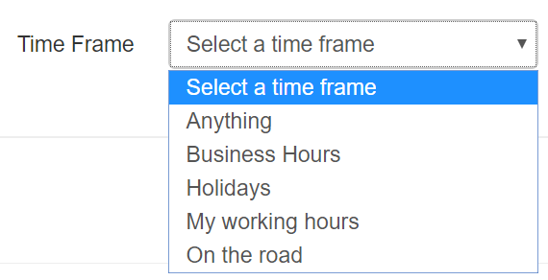
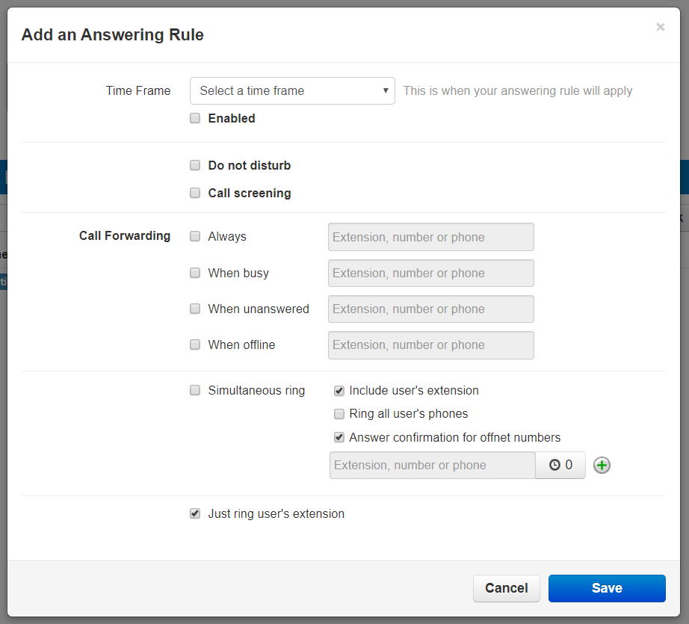
On the Add Answering Rule window you will see the Time Frame drop down as seen in figure 4.8.3.b. Time Frames are a set period of time which covers when we want certain events to occur, such as our phone to ring. Select the Time Frame you would like the new rule to take effect.
4.8.3.a
The Enable check box allows you to enable or disable the rule. Check box means the rule is enabled. Unchecked means the rule has been disabled.
4.8.3.b

Do Not Disturb
4.8.3.1
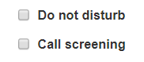
The Do not Disturb option as seen in figure 4.8.3.1. Which will prevent calls from reaching your devices and send the call to voicemail if voicemail is enabled or disconnect the call if voicemail is not enabled.

Call Screening
Underneath you will see Call Screening. When Call screening is enabled, callers record their name. After they record their name, then your devices will ring. If you answer the call, it will play the users name and allow to press 1 to be connected or hang up the call and have them be sent to voicemail or wherever your Call Forwarding options are configured to send unanswered calls.
Fig.4.8.3.3

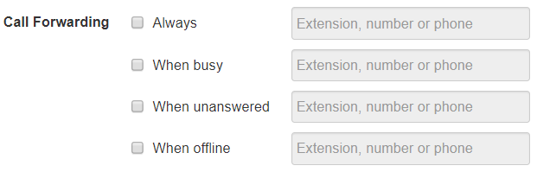
Call Forwarding
The Call Forwarding options as seen in figure 4.8.3.3 will route calls based of the options select and your activity.

Always
Always, which will forward the call to the destination entered in the Extensions, phone number, or phone field. You can enter an extension of another user. Another phone number which does not have to be on this system, it can be a cell phone or any number you desire. Or it can be a specific device. Or even a voicemail box.

When Busy
When Busy forwards calls only when you are already on the line or busy.

When Unanswered
When unanswered dictates where to send the call when the Ring For X Seconds has been reached.

When Offline
When Office routes the call to the desired destination entered into Extension, number, or phone field when the user’s devices are offline. If you use a softphone on your laptop and shut down the softphone this is where your calls are forwarded to.

Simultaneous Ring
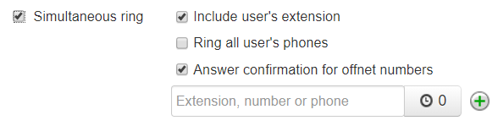
The Simultaneous Ring options, also known as SIM ring for short, seen in figure 4.8.3.8 allows you to configure what devices ring when receiving a call. Clicking the Simultaneous Ring box will allow you to ring more than just your extension and allow you to ring other extensions or phone numbers as well.
Figure 4.8.3.8

Include user’s extensions
Enabling this option will make sure your extension rings when sim rings is enabled.

Ring all user’s phones
This option will ring all devices registered to your account.

Answer confirmation for off net numbers
This option lets the user know the call is forward to that it is a forwarded call from their phone system and gives them the option to be connected to the user by pressing 1 or hanging up the call so they are not connected with the forwarded party.

Add Calls to SIM Ring
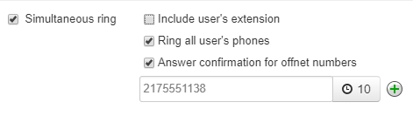
To add phones to the Simultaneous Ring for the call to be forwarded to enter the extension, number, or specific devices you would like to forward the call too like in figure 4.8.3.1.1.
Figure 4.8.3.1.1

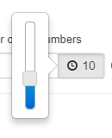
The clock icon next to the extension number or phone field is a ring delay as seen in figure 4.8.3.1.1. You can delay this device from ringing in 5 second increments.
If you wanted a call that came into your extension to ring your cell phone if the call was not answered in 10 seconds you would configure the field to the right with your cell phone number. Then click the ring delay icon and slide the ring delay up to 10 seconds.
4.8.3.1.1
If you wanted another extension to ring after 15 seconds had gone by and the call was still not answered, click the plus sign.
Another field to enter an extension, phone number, or specific device appears. Enter the destination you would like to forward the call to as well. Then set the ring delay to 15 seconds as seen in figure 4.8.3.1.1.a
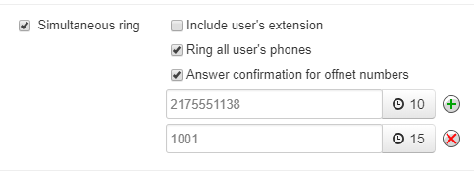
Now when a call reaches us, it is
4.8.3.1.1.a
routed to our extension. If the call is not answered in 10 seconds, then our extension and cell phone will start ringing. If the call is still not answered after 15 seconds our extension, our cell phone, and the other extension will start to ring.
Once an extension starts to ring it will continue to ring unless the call is answered, or the caller disconnects the call.
If you are looking to have a device stop ringing and more onto another device or phone number, talk to your office manager about configuring a Call Queue.

Just ring user’s extension
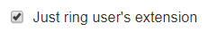

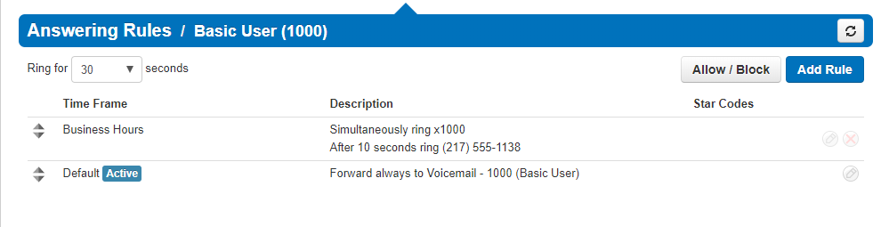
The final option is Just ring user’s extension which can be enabled by disabling Simultaneous ring then clicking the check box next to Just ring user’s extension as seen in figure 4.8.3.12.
For any of these changes to take effect you must click Save. If you do not want the changes to take effect, click Cancel as seen in figure 4.8.3.12.a.
Once a rule is created you can drag and drop them to prioritize them as seen in figure 4.8.3.12.b. Rules are read in a top to bottom format meaning the system checks the 1st rule to see if the Time Frame for that rule are in effect.
4.8.3.12.a
4.8.3.12
If the Time Frame selected for the Answering Rule is in effect it will follow the action configured in that rule. If the call is not occurring during the Time Frame selected for the answering rule the system will then check the next Answering Rule below and so on until it finds a rule with an active Time Frame as seen in figure 4.8.4. The 1st rule the system sees with a time frame in effect is the rule the system uses to route the call.
4.8.3.12.b

Answering Rule configuration example
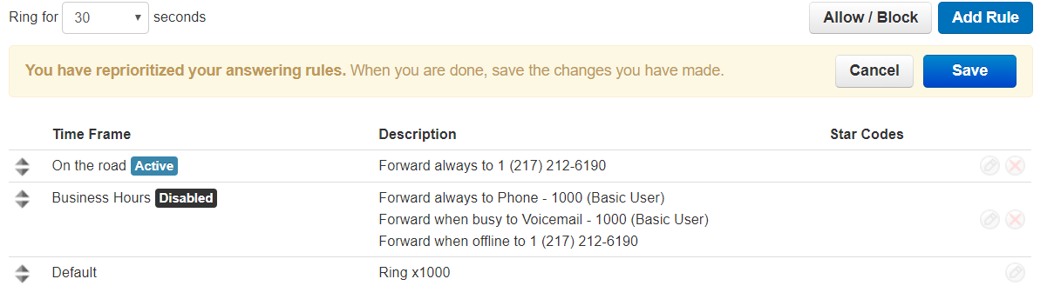
4.8.4
- If we wanted our phones to ring during business hours.
- After hours we wanted calls to go directly to voicemail.
- Then Friday we were out of the office and wanted calls to go to our cell phone.
First, we would configure the default rule to send calls directly to Voicemail as seen in figure 4.8.4.b.
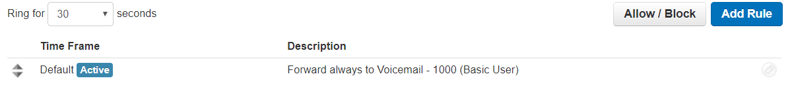
4.8.4.b
We would create a rule and select the Time Frame for our business hours. Configure the call forwarding and SIM ring to our liking then drag the rule above the default rule as seen in figure 4.8.4.c.
4.8.4.c.
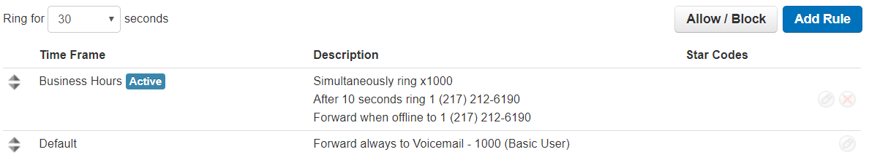
We would then create an answering rule with the out of office Time Frame selected and drag that rule to the top as seen in figure 4.8.4.d.
4.8.4.d
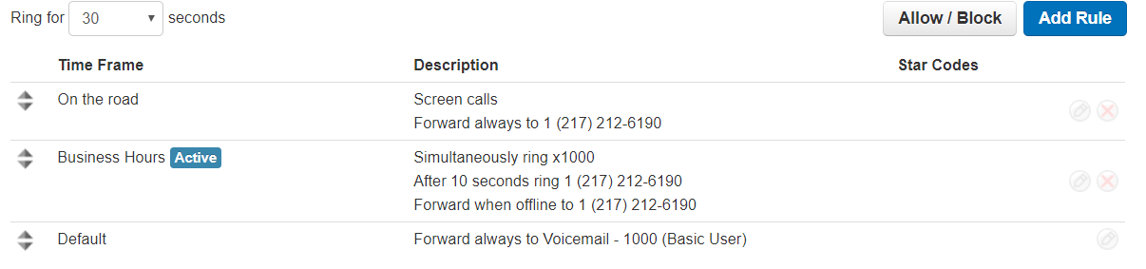
We would drag the vacation answering rule to the top. Then we would drag our rule we created for our open business hours under the out of office answering rule. Finally, we would have our default rule on the bottom.
Now if a call came in Monday through Thursday during our normal business hours, the Vacation rule would be ignored as the time frame is not in effect. The system would then look at the next rule underneath. The open hours rule would then take effect as the call came in during that time frame and would route the call based on the options selected in that rule.
Now if a call came in after our normal business hours on Monday through Thursday. It would check the 1st rule, see that time frame is not in effect then move onto the next rule.
It would see the call time does not fall within the Time Frame of the second rule so the system will move onto the next rule. The default rule uses the default time frame which is active 24/7 so this rule would take effect.
Now if a call came in on Friday during our normal business hours, the system would check the vacation rule. See that the call is during this time frame and use the vacation answering rule to forward the call.

Always remember the system reads the answering rules in a top-to-bottom order and will use the first rule with an active time frame to route the call. If a call is not being routed using a rule you want, then there is another rule the call time frame is matching. Answering Rules are how you control what devices ring, how long those devices ring for, and what to do with the call if it is not answered.

Your Time Frames
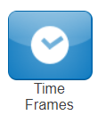
The Time Frames icon as seen in figure 4.9 will take you to the Time Frames application center. Time Frames are a set period of time which covers when we want certain events to occur, such as our phone to ring.
We create Time Frames with different time and date ranges so we can apply them to answering rules which then allow you to control how calls are routed depending on the time of the day the call occurs.
4.9
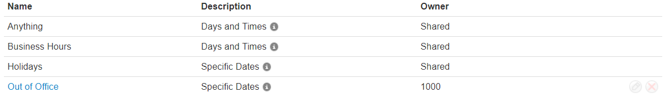
To view and create your available Time Frames click on the Time Frame icon in the top navigation menu bar. Here you will see all the time frames available for you as displayed in figure 4.9. Time frames with names in black and without the option to edit or delete are time frames created at the domain level that are available to everyone in the domain to use. You can only edit the time frames with blue name that you created. If you need domain level Time Frames changed contact your Office Manager.
Figure 6.1
Figure 4.9

Adding Time Frames
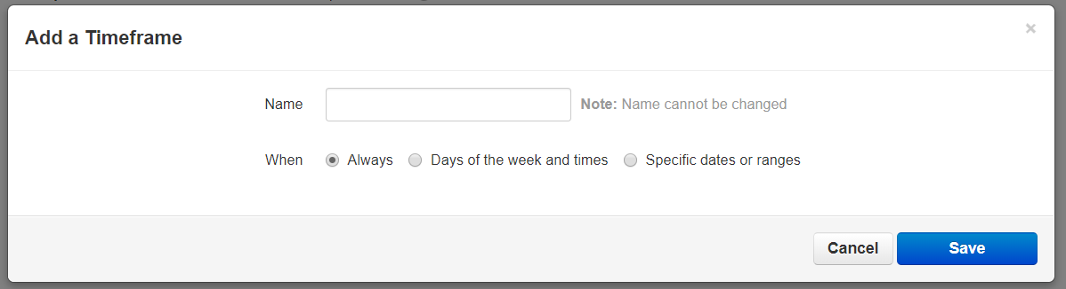

To create a time frame, click on the Add Time Frame button as seen in figure 6.1. After clicking Add Time Frame button the Add Timeframe window will appear as seen in figure 6.1.1
Figure 6-1-1

The Name field allows you to give the Time Frame a name that will help identify the rule. The name cannot be changed once the rule as been created. If you want to change the name delete the rule and recreate it with the new name.
Under the name field, you see three options for when the time frame should be in effect:

Always
This option makes this rule always in effect 24 hours a day 7 days a week 365 days per year.

Days of the week and times
Which allows you to select specific days of the week and the hours in the day you want the time frame to take effect. When selecting this option, the days of the week appear with a check box that allow you select which days you would like the time frame active. Once selecting a day of the week, a blue bar appears allowing you to slide the ends to when you would like the time frame to stop and start as seen in figure 4.9.1.2. If would like your time frame to be in effect from 7am to 7pm, simply click on the edge of the blue bar and slide them over to the desired time as seen in figure 4.9.1.2.a.
4.9.1.2
4.9.1.2.a.

If you’d like a break in the middle of the time frame click the plus sign next to the 11:59m as seen in figure 4.9.1.2.b. You will then see another blue bar appearing representing when the time frame will take effect as seen in figure 6-1-5.
4.9.1.2.b

Specific dates or ranges
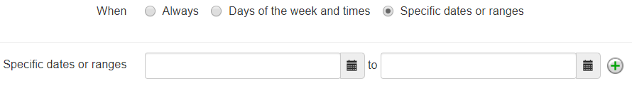
This option will allow you to configure a time frame to be in effect for specific dates. After selecting the Specific date or ranges options you will see the to and from dates as seen in figure 4.9.1.3.
4.9.1.3
When clicking in the To or From date fields a calendar will appear as seen in figure 4.9.1.3.a
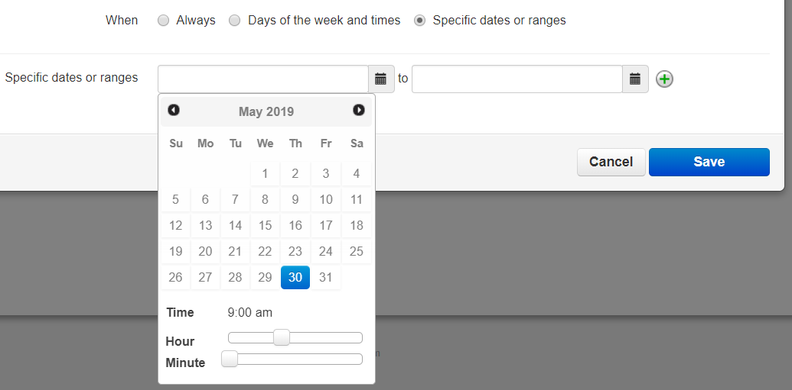
4.9.1.3.a
Then select the end date you would like the time frame to start and stop. Below the calendar is the Hour and Minute options so you can configure your time frames to start and stop certain hours on the selected dates.
Clicking the plus sign will all you to add more date ranges for the time frame to be in effect.
4.9.1.3.b
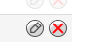
Once a Time Frame has been created you can change the time frame and time by clicking the edit icon next to it. To remove the time frame, click the delete icon next to the time frame as seen in figure 4.9.1.3.b.


Phones

The phone icon as seen in figure 7 will take you to your phones center and will display your list of what devices are registered to your account as seen in figure 4.10
4.10
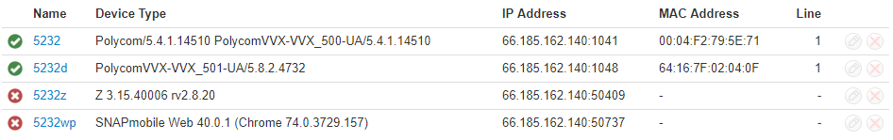
A green icon next to the device means the device is registered and will be able to send and receive calls without issue.
4.10

A red icon means the device is unregistered. This could be caused because the device is softphone and currently turned off. Or the phone system is unable to communicate with the device.

To the right of the status indicator is the name of the device. Followed by device type, the manufacturer and model number of the device, the IP address the device is registered at, the MAC address of the device.
And finally, the line number the device has the extension number displayed.

Music on Hold

Clicking the Music on Hold icon as seen in figure 4.11 will take you to your accounts music on hold center and will list all the custom music uploaded to your account that is played when you place someone on hold as seen in figure 4.11.a.
Music played in a top-to-bottom order or randomized depending how the queue was created.
4.11
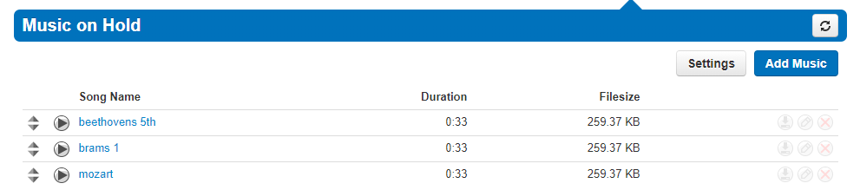
4.11.a

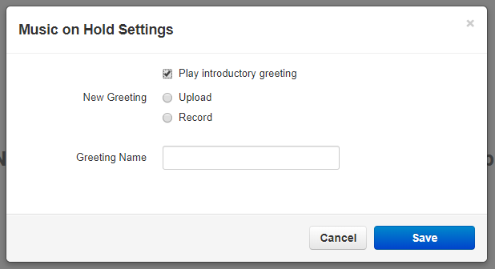
Music on Hold Settings
Clicking the setting button will display the Music On Hold Settings as seen in figure 8.1 which allows for the option Play introductory greeting to be enabled. When the option is selected, you will be asked to upload a WAV or mp3 file of the introductory greeting. This introductory greeting will always play first when someone is placed on hold then music afterwards.
4.11.1


Add Music on Hold to your account
The Add Music button as seen in figure 4.11.2 will allow you upload an mp3 or WAV file format and name the music on hold file.
4.11.2

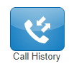
Your Account Call History
The Call History icon as seen in figure 4.12 will take you to the Call History page. Where you will see the calls made to and from your account for the specified date range as seen in figure 4.12.a.
4.12

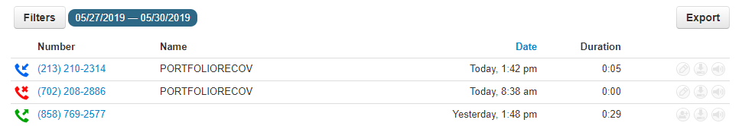
4.12.a

Call History Filters
You can change the date range by clicking the Filters button as seen in figure 4.12.1.
4.12.1
4.12.1.a
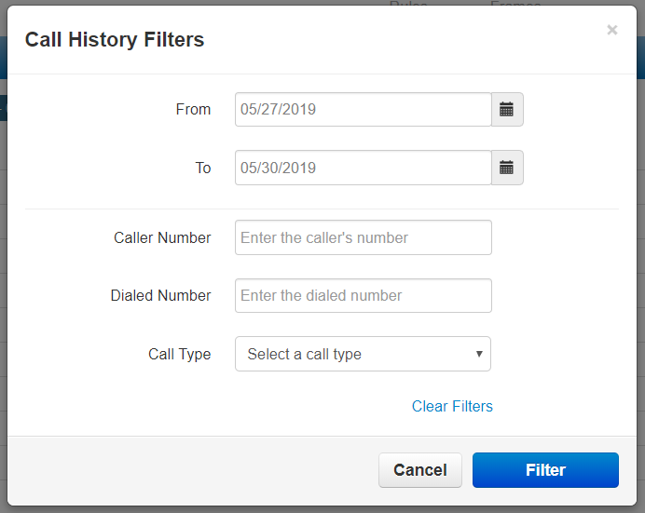

After clicking the filter button, the Call History Filters window will appear as seen in figure 4.12.1.a. Here you can change the Call History date range.

Caller Number
Allows you to search for calls from a specific phone number by entering the number into the Caller Number field.

Dialed Number
The Dialed Number field will let you filter for a specific number that you dialed.

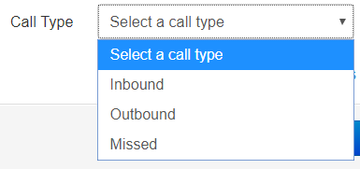
Call Type

The Call Type drop down as seen in figure 4.12.4 lets you filter based off the type of call. Inbound, Outbound, or Missed call.
4.12.4
Clicking the Filter button as seen in figure 4.12.4 will then display

Calls displayed with a red x are missed calls.

Calls displayed with a green arrow are outbound calls.
Calls displayed with a blue arrow are inbound calls that were answered.
4.12.4.a
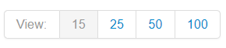
You can set the Call History to display 15, 25, 50, and 100 calls per page as seen in figure 4.12.4.a.


The caller can be added to your contacts by clicking the Add Contact icon as seen in figure 4.12.4.b.
4.12.4.c
4.12.4.b
You can add a call to your contacts by clicking the Edit Icon next to the call which will display the contact information fields as seen in figure 4.12.4.c.

4.12.4.d
If call recording is enabled for your profile, device, or if the call was from a queue configured to record calls you can download the call clicking the Download icon as seen in figure4.12.4.d.


9-1-7
If you’d like to listen to the call without downloading the call you can click the listen icon as seen in figure 9-1-7 which will open a media player right in your browser as seen in figure 9-1-8
Figure 9-1-8

4.13

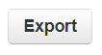
Exporting Call History
The export icon as seen in figure 4.13 allows you to download the call history into a csv file that can be opened in any spreadsheet application such as Excel or Apache Open Office.
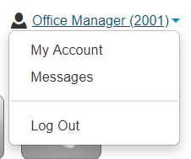

Log Out
This option as seen in figure 4.14 will log your extension out of the portal and take you back to the portal login page.
4.14

Organization Level
When in your account level you can access the organization by click the Manage Organization Link as seen in figure 5.
5

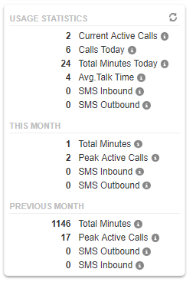
Usage Statistics
5.1
On the home page of the organization level you will see the Usage Statistics widget as seen in figure 5.1 which provides an overview of how many
- Current active calls your organization has connected.
- Total number of calls that have been made today and the total number of minutes used.
- As well out how many inbound and outbound SMS messages have been sent.
- Followed by the usage statistics for the month and the previous months totals.

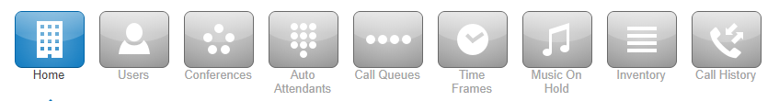
Application Menu
5.23
At the top of the Manager portal is the application menu as seen in figure 5.2 Where you will see by default the options for:

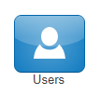
Users

The Users icon as seen in figure 5.3 will take you to the users center as seen in figure 5.3.a. This is where you can create and manage the users on your domain. Users are destinations we want to send calls to. Every person’s account, Conference Bridge, Auto Attendant, Call Queue in the organization is a User.
5.3

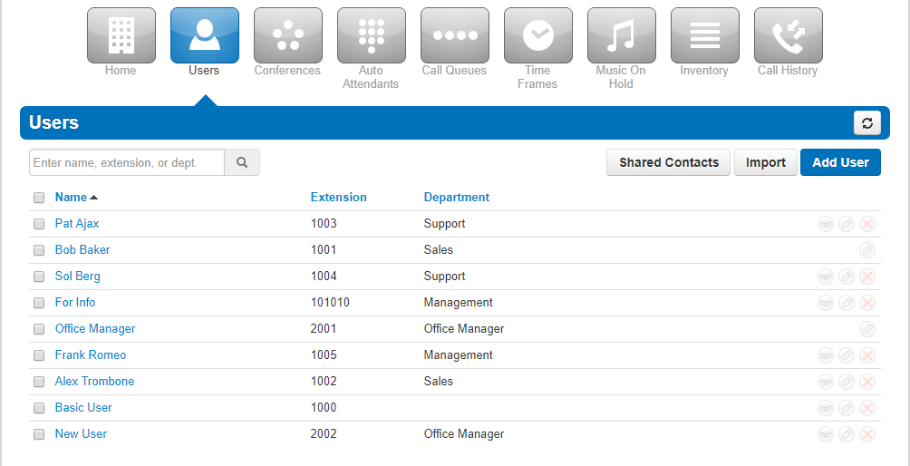
5.3.a

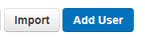
Bulk Import Users
The Import option as seen in figure 5.3.1 will allow you bulk import users from a CSV file. Shared Contacts will create contacts that will be shared across the organization for all users to have in the contacts.
5.3.1

Creating a New User
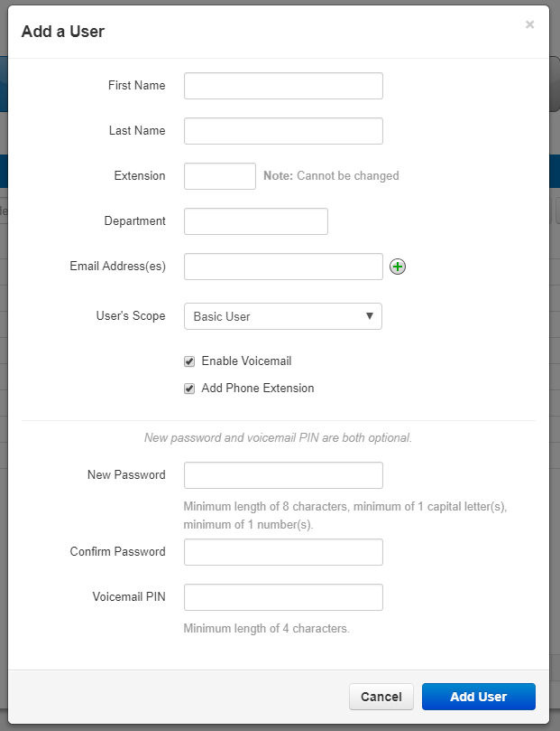
To create a new click the Users icon in the Manager Portal navigation option. Here you will see the option to Add User as seen in figure 5.3.1. Clicking the Add User button will display the Add User window as seen in figure 5.3.2 and fill out the fields with the collating information.
5.3.2

Scopes
Scopes are a level of permissions we assign to a User which provide them access to various features. Clicking the scopes drop down as seen in figure 5.3.3 will display the various scope level that can be assigned to the new user.

Simple User
Has no manager portal access.

Basic User
Is a user that can login to the Manager Portal

Advanced User
Configures the user scope with an advanced user

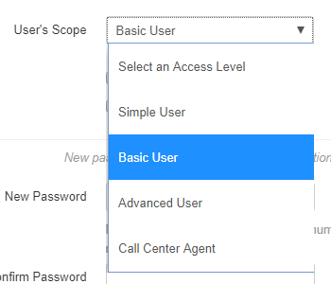
Call Center Agent
5.3.3
Can login in and out of queues.

Add Phone Extension
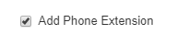
The Add phone extension option will create a device under the phones tab.

User Options
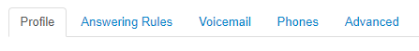
After the User has been created you can then click on the User and you will the tabs in figure 5.3.5 appear:
5.3.5

- Edit their profile information.
- Set their answering rules.
- Configure their voicemail options.
- You and add a new phone to the users account by clicking the Add Phone button.
- Edit or Delete an existing phone.
- The Advanced Options Allow you to Reset the User.
- Send a Welcome with a link to configure their password and voicemail pin
- Force Password Reset Allow you to change the user's password.

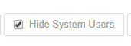
Hide System Users
5.3.6

The Hide System Users option as seen in figure 5.3.6 will filter for just User’s accounts. Uncheck will display Conferences Bridges, Auto Attendants, and Call Queues user accounts.


Conference
The Conference icon as seen in figure 5.4 will take you to the Conference center as seen in figure 5.4.a, where you can manage your organization's conference bridges.

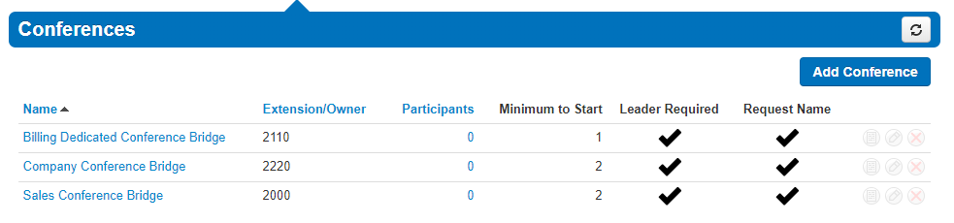
Conference bridges are used to make conference calls. A telephone call in which someone talks to several people at the same time. The conference calls may be designed to allow the called party to participate during the call, or the call may be set up so that the called party merely listens into the call and cannot speak. The Conference icon will take you to the Conference Center where you can control your organization’s conferences bridges.
5.4
5.4.a

Creating a new Conference Bridge
You can create a new conference bridge by clicking Add Conference button as seen in figure 5.4.a then filling out the fields displayed in the window.

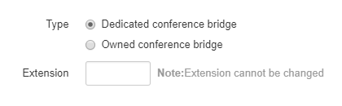
Dedicated Conference Bridge
5.4.2
The Dedicated conference bridge options as seen in figure 5.4.2 creates a conference bridge that only you will be able to modify.

Owned Conference Bridge
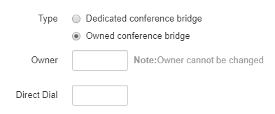
The Owned Conference Bridge options as seen in figure 5.4.3 creates a conference bridge that the owner can modify. For an owned conference bridge the system will ask you for the extension of the owner.
5.4.3

Direct Phone Dial
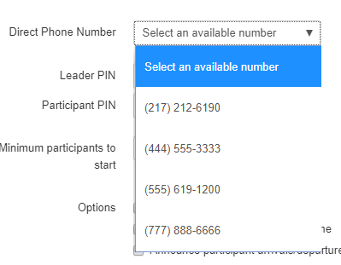
The Direct Dial drop-down as seen in figure 5.4.4 is what you will dial to reach the user's conference bridge directly. If you have available phone numbers, you can assign them to the conference bridge by selecting them from the drop-down.
5.4.4

If you do not see any phone numbers in the drop down that means there are no available phone numbers and one must be added to the inventory by your administrator or you can select a number already pointing to another destination and reconfigure to point to the conference bridge.

Leader PIN
The Leader PIN is what people who will be administering the conference bridge enter when joining the conference. Leaders can enter star codes to manipulate the behavior of your conference bridge.

Mid Conference Actions
[*]6 | Toggle Mute |  | Toggle Mute On/Off
[*]71 | Start Recording |  | Recording On
[*]73 | Stop Recording |  | Recording Off
[*]74 | Dec Rx Gain |  | Decrease volume to participant
[*]75 | Reset RxGain |  | Reset volume to participant
[*]76 | Inc RxGain |  | Increase volume to participant
[*]77 | Dec Tx Gain |  | Decrease volume to conference
[*]78 | Reset TxGain |  | Reset volume to conference
[*]79 | Inc Tx Gain |  | Increase volume to conference
[*]91 | List Participants |  | To announce the list of active participants
[*]92 | Toggle Announce On/Off |  | Toggle Announcement On/Off
[*]93 | Disconnect All |  | Disconnect All Other Participants
[*]94 | Toggle Conference Lock |  | Toggle Conference Lock
[*]95 | Count Participants |  | To announce the count of active participants
[*]96 | Mute All |  | Mute All Other Participants
[*]97 | Unmute All |  | Unmute All Other Participants
[*]98[0-9][0-9][0-9][0-9] | Speaker Sign-On |  | Sign-on as Speaker
[*]99[0-9][0-9][0-9][0-9] | Leader Sign-On |  | Sign-ON as Leader

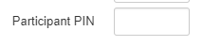
Participant PIN
The Participant PIN as seen in figure 5.4.6 is what people that we just want to be able to join the conference bridge without having any elevated privileges and only be able to listen and speak when unmuted.
5.4.6

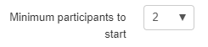
Minimum Participants to Start
Minimum participants to start will keep the music on hold playing until the minimum participants have joined the conference bridges.
5.4.7

Conference User Experience Options
The Options as seen in figure 5.4.8 below let you control the user experience when a party joins the conference bridge.
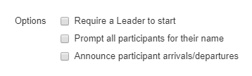
5.4.8

Require a Leader
Require a Leader to start will keep the music on hold playing for all parties until someone joins the conference bridge and enters the leader pin.

Prompt all participants for their name
Prompt all participants for their name will ask the user to record their name and play the recording to people already in the conference bridge when joining.

Announce participant arrivals/departures
Announce participant arrivals/departures will play the recording of the user's name when people enter or exit the conference bridge.

Conference Bridge Reports
After the conference bridge has been created you will see the option to run reports.

Edit Conference Bridge
Edit the conference bridge and allow you to change any of the options selected when creating a conference bridge expect the extension number. And the option to delete the conference bridge.

Delete Conference Bridge
To delete click the red x that appears to the right of reports and the edit option as seen in figure 5-4.

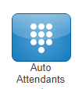
Auto Attendants
5.5
Auto Attendants icon as seen in figure 5.5 will take you to the Auto Attendants center as seen in figure 5.5.a. Auto Attendants are interactive voice recordings that allow callers to make selections in order to route their call to their desired destination.
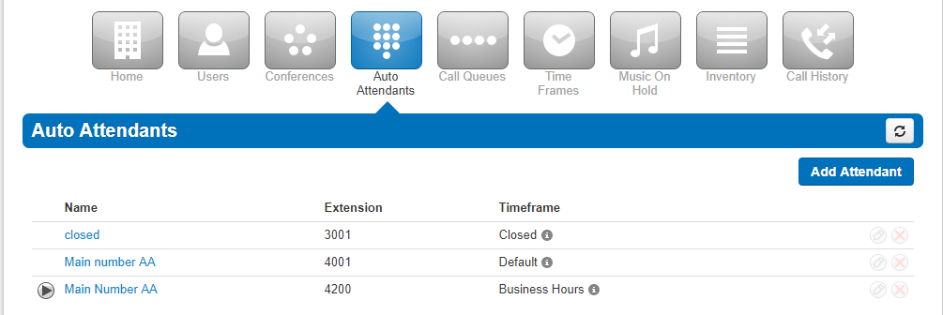
The most common use case for an Auto Attendant is having the main company phone number pointed to an Auto Attendant. When callers then call into the business, they can be routed to the party they are trying to reach by listening to the menu prompt options or dialing a user’s extension directly.
5.5.a
Clicking the Auto Attendants icon on the top of the manager portal navigation options will take you to your Auto Attendant center.
Here you can Edit existing Auto Attendants, delete them, and create new ones.
5.5.1

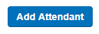
Creating a new Auto Attendant
To add an Auto Attendant, click the Add Attendant button in the top right as seen in figure 5.5.1.

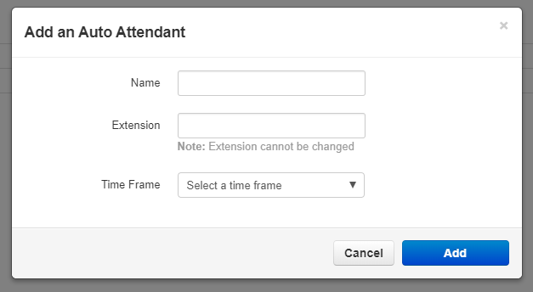
The Add an Auto Attendant window will appear as seen in figure 5.5.1.a.
5.5.1.a

Name the Auto Attendant and give it an extension. Note the extension cannot be changed once the Auto Attendant has been created.

Then select a Time Frame for the Auto Attendant to be in effect.

Click Add to create the Auto Attendant.

Intro Greeting
Once the Auto Attendant has been created Click the Intro to record the first message the caller will here.

Clicking on the speaker next to the Manage Greetings will display he Manage Greetings window as seen in figure 5.5.2. Here you can Upload a new intro greeting or record a new one. Then you can select a time frame for that message so it will only play during the selected time frame.

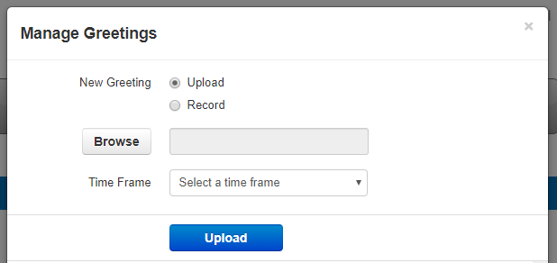
5.5.2

Menu Prompt
Clicking the speaker icon next to Menu Prompt option as seen in figure 5.5.3 will allow you to record a message letting callers know what digits will route them to what application or destination.

Dial Pad Menu
The Dial Pad Menu options as seen in figure 5.5.3 is where you configure what digits correlate with an application. When you select a digit, you will see the applications you can choose from. Click on a digit and you will see the applications you can assign to it. When clicking on a digit and selecting an application you can see the options you can configure the application with.
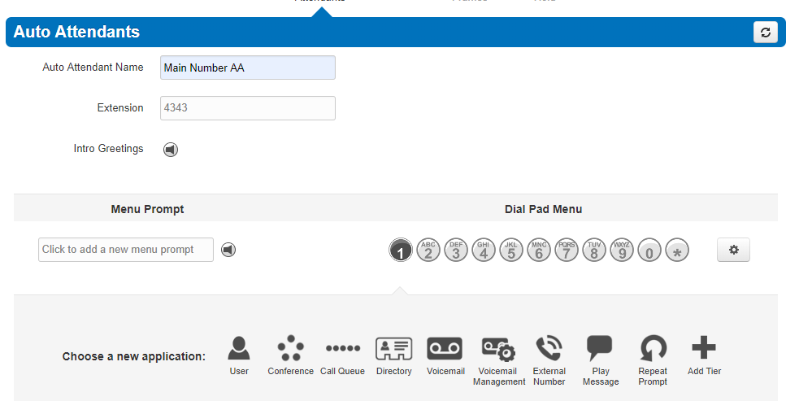
5.5.3

User
The User application as seen below will allow you to forward the caller to an extension on the system of another user. It will also give you the option to add a prefix to the call ID so the user that call is being forwarded to knows the call is being routed from an auto attendant.

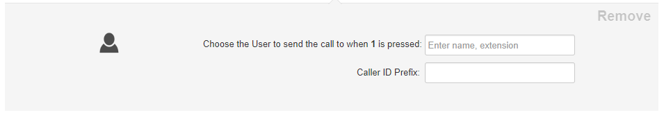

Conference
The Conference option as seen below will allow you to forward the call to the conference bridge you enter into the Enter bridge name, extension option field.

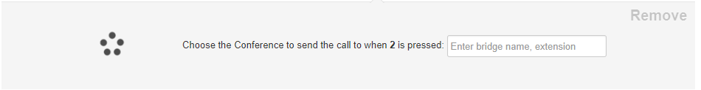

Call Queue
Call Queues options as seen below allows the caller to be forwarded to a call queue.
  - It also allows you to have the system announce the number of callers in the queue ahead of the caller.
  - Or announce the average expected wait time.
  - It also allows for a Caller ID prefix to be added so the agent in the queue knows the call was routed to them from an Auto Attendant.
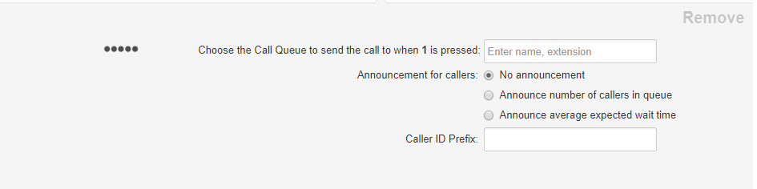

Directory
Directory option as seen below sends the call to the company directory.

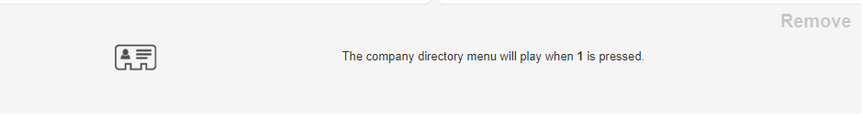

Voicemail
Voicemail option as seen below will forward a caller to the voicemail extension entered.

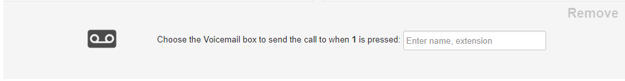

Voicemail Management
Voicemail Management option as seen below allows users on the system to enter their extension number and pin. Then they can check messages and manage their voicemail account.


External Number
External number option as seen below will forward the call to another telephone number.



Play Message
Play message option as seen below allows you to record a message that will be played to the caller. Then you can decide how to route the call after the message has been played.

Repeat Prompt will replay the menu prompt message.

Add Tier
Add Tier option as seen below will allow you to add another dial pad menu to the auto attendant.

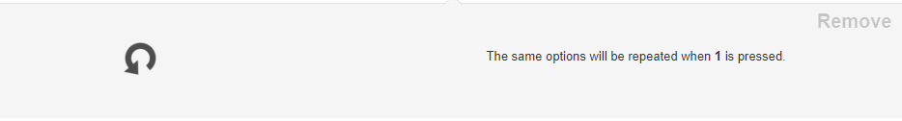

Once another tier has been added you will see the same options except for Add Tier. As you cannot add another tier. And the option for the Previous Menu appears so the caller can route back to the original Auto Attendant level. You cannot add a tier to 0 or the star key.

Options
The Gear Icon takes you to the options settings window for the Auto Attendant as seen in figure 5.5.5 where you can control the caller’s experiences.
5.5.5
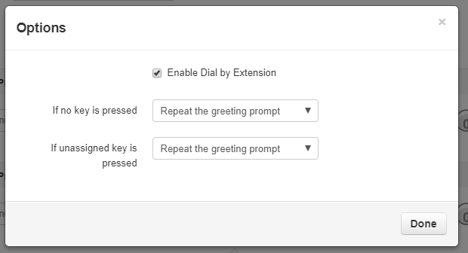

Enable Dial by Extension
Enable Dial by Extension allows you to enable calling an extension directly from the Auto Attendant if the caller knows the user's extension number.

If no key is pressed
Allows you to select a dial pad menu option, repeat the menu prompt recording, or hang up the call if no digit is pressed when the caller is in the Auto Attendant.

If unassigned key is pressed
Configure what to do with the call if the caller does not press any digits when in the auto attendant and what do to if the caller presses a key that is not configured in the Dial Pad

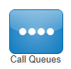
Call Queues
The Call Queues icon as seen in figure 5.6 will take you to the Call Queues center as seen in figure 5.6.a.

A Call Queues is place holders for calls to sit waiting to be answered. A call queue can be configured to ring multiple devices in a certain order or a parking lot for a call to sit and wait until someone retrieves the call.
5.6

To navigate to the Call Queues center, select Call Queues from the manager portal navigation icons. If the domain has any Call Queues configured, you will see them displayed here.
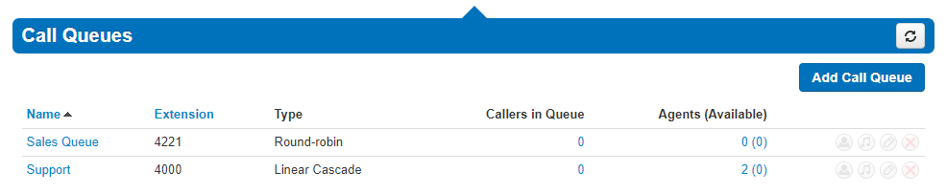
5.6.a

Add Call Queue

To add a call queue to the domain, click the Add Call Queue button as seen to the right in figure 5.6.1. You will be taken to the Add a Call Queue window Basic tab as seen in figure 5.6.1.a.
5.6.1
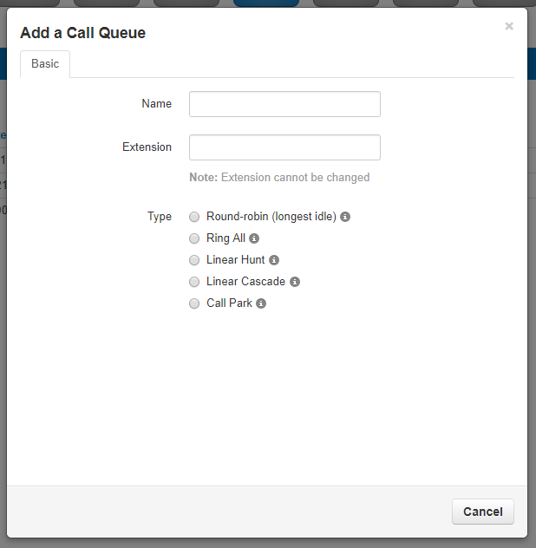
5.6.1.a

Basic Tab
The basic tab will ask you for basic information needed such as the name you would like to give the queue and extension number. The Extension number cannot be changed once the queue is created.

Ring Type
The Ring Type controls how the call is sent to specific devices. Calls are sent to specific devices instead of users so their Answering Rules will not route to an undesired destination.

Round-robin
Routes callers to the available agent that has been idle the longest so the agents that has not received a call in the longest amount of time will receive the call.

Ring All
Simultaneously rings all available extensions in the queue. First agent that answers gets connected with the caller.

Linear Hunt
Linear Hunt calls agents in a predefined order. The order is defined when editing the queues agents after the queue has been created.

Linear Cascade
Linear Cascade routes calls to groups of available agents in a predefined order. The order is defined when editing the queues agents after the queue has been created.

Call Park
Call Park allows users to send callers to an extension to wait until the call is retrieved by the person sending the call o the parking lot or by another user on the system. Selecting Call Park will not display Pre Queue Options or In Queue Options. Nor will the options to select a phone number for direct dialing, recording calls, or collecting statistics.

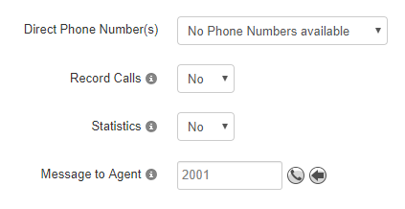
Direct Phone Number(s)
You can select a phone number that will route directly to the Call Queue being created if your organization has any available phone numbers.

Record Calls
Setting Record calls o Yes will record all calls that are routed through the queue being created.

Statistics
This option will collect statistics for the queue being created and provides information to the Call Center Supervisor.

Message to Agent
After the queue is created you can click the edit icon and the option to record a message that will be played to the agent every time the agent answers a call from the queue will appear.

Pre Queue Options tab
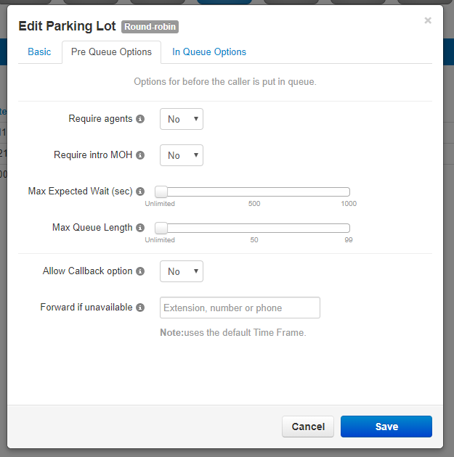
If you select any other ring type than Call Park the Pre Queue Options tab will appear as seen in figure 5.6.3. The Pre Queue Options are a set of conditions that must be met before the queue will accept the call. If any of the conditions are not met the call will be forwarded to the destination in the Forward if unavailable field.
5.6.3

Require Agents
Enabling Require Agents will configure the queue so agents must be signed in or the call will be forwarded to the Forward if unavailable destination.

Require Intro HOM
Setting Require intro MOH (Music on Hold) will play the first recording in the Music on Hold directory of the queue to the caller when they enter the queue.

Max Expected Wait
Max Expected Wait allow you to add a cap to how long the hold time can for callers.
If you set a time and the Max Expected Wait time and it is exceeded for a new caller entering the queue the caller will be sent to the destination entered into the Forward if unavailable field.

Max Queue Length
Allows you to set a cap of how many callers the queue can have waiting at one time. If a Max Queue Length is set and a caller attempts to join the queue it will forward them to the destination entered in the Forward if unavailable field.

Allow Callback Option
The Allow Callback options allow for callers entering the queue to save their place in the queue and receive a call from the system when an agent is available.

Forward if unavailable
The Forward if unavailable field forwards calls to the destination entered if the queue has reached it’s expected max wait or the max queue length limit has been reached. Clicking next will take you to the In Queue Options tab.

In Queue Options
The In Queue Option tab as seen in figure 5.6.4 allows you to control how the call is handled if the call meets all Pre Queue Options and the call is accepted into the queue. This tab will change based on the ring type selected.

Queue Ring Timeout (secs)
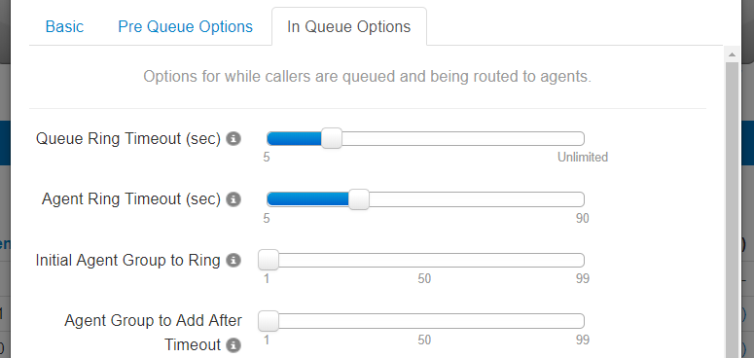
Queue Timeout is a time limit that can be set for how long a call will remain in the queue before being forwarded to the destination entered into the Forward if unanswered or voicemail of the queue. Moving he blue bar to the right will increase the amount of time in 5 second intervals. Move all the way to the right for unlimited. Which will permanently keep he call in the queue until someone answers or the call disconnects.
5.6.4

Agent Ring Timeout
Agent Ring Timeout allows you to configure how long each agent in the queue phone will ring before moving onto the next agent. This option will not display if the call type of the queue is Ring All.

Initial Agent Group to Ring
This option will appear if Linear Cascade is the selected call type. This adds an additional group of agents to ring when the Agent Ring Timeout is reached. The queue will ring the first group of agents and added agents with the chosen order or lower to simultaneously ring. You will see the option to assign an order to the agents after the queue is created on the Edit Agents page under the Order in Linear Hunt option that appears.
For example, if you chose 5 for Initial Agent Group to Ring and 5 for this option it will now ring all agents with the Order of 10 or lower. It will add 5 and ring all agents with that Order or lower on every Agent Ring Timeout that is reached. You will see the option to assign agents an order after the queue is created

Logout agent on missed call
5.6.4.4
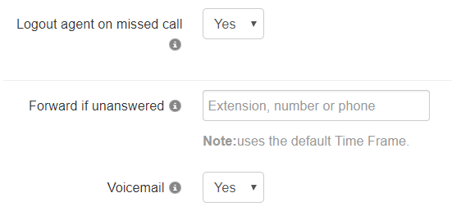
Logout agent on missed call option as seen to the right in figure 5.6.4.4 will log an agent out of the queue if a call from the queue goes unanswered.

Forward if unanswered
Forward if unanswered option as seen in figure 5.6.4.4 allows you to enter a destination for calls that are not answered. This could be another user’s extension number or another phone number.

Enabling Voicemail
Enabling Voicemail will create a voicemail box for the queue and allow callers to leave a voicemail if no Forward if unanswered has been set.

Managing Call Queue
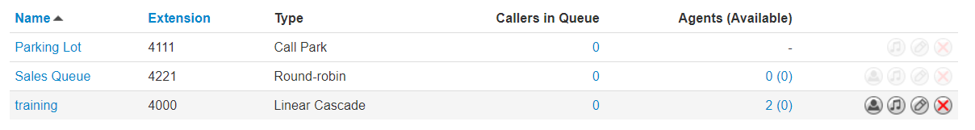
Clicking Save will create the Call Queue. You will then see the call queue displayed with your other call queues. To the right of the queue name and extension you will see the ring type selected for the queue and an overview of how many callers and agents are in the queue. You will also see the options to Add Agents, Edit the Music on Hold, Edit any of the options selected when creating the queue excepts for the name or extension number, and delete the queue.

Edit Agents
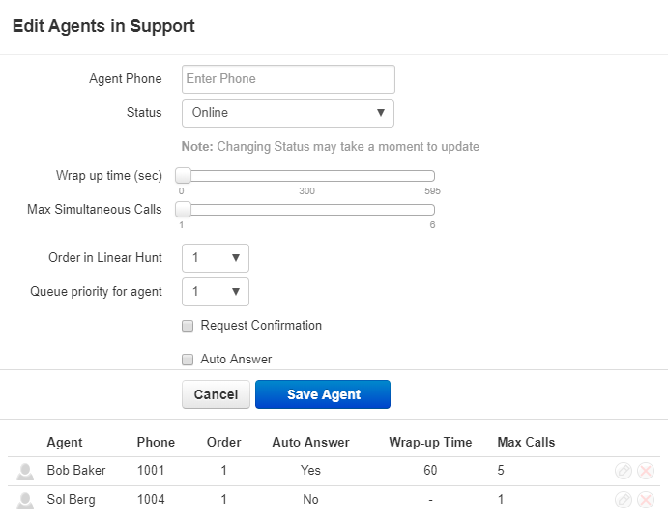
The Edit Agent icon will take you to the Edit Agents page as seen in figure 5.6.6. Here you can add agents to the queue. Modify if they are able to receive calls and how many calls they can receive at one time.
5.5.6

Agent Phone
The Agent Phone field is where you enter the device of the agent you want to receive calls from the queue. You add agent’s specific phones you want to ring and not users so the users answering rules do not control how the call is routed rather than how the queue options are configured to route the call.

Status
The Status has two option Online and Offline. If an agent is online they are able to receive calls from the queue. Offline will add the user however they will not be sent queue calls. This is useful when you want to assign Call Center Supervisors to a queue that you want them to manage however not take calls from.

Wrap Time
Wrap Time will not send the agent another call from the queue until that threshold has been reached.

Max Simultaneous Calls
Max Simultaneous Calls allows you to configure if the agent can receive multiple calls from the queue and how many total they can receive at one time.

Order in Linear Hunt
Order in Linear Hunt assigns the call queue agent to that position in the linear hunt order to ring.

Queue Priority
If an agent is being added to multiple queues, Queue Priority decides which queue will ring the agent when calls are waiting in multiple queues for the agent to answer.

Request Confirmation
Will inform the agent they are receiving a call from the queue and to press 1 to accept the call. If calls are routed to an off-net number and request confirmation is not enabled the phone receiving the call voicemail could answer the call preventing the call from going to the next agent in the queue.

Auto Answer
Auto Answer will have the call automatically answered by the phone being sent the call.

Save Agent
The Save Agent button will add the agent’s phone to the devices that will ring when there is a call in the queue.

After adding the agent’s device you can change any of these options by clicking the Edit Icon as seen in figure 5.6.6.9. You can also remove the agent’s device by clicking the delete icon.

5.6.6.9
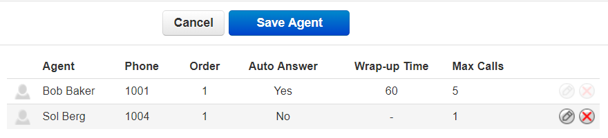

Edit MoH (Music on Hold)
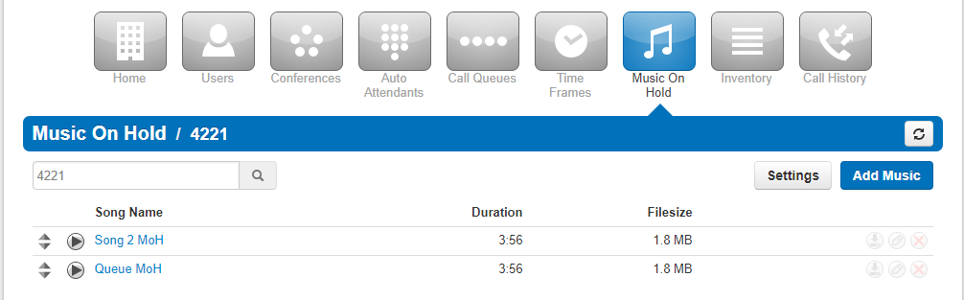
To the right of the Edit Agent icon on the Call Queues center page is the Edit Music on Hold Icon. Clicking the Edit MoH will take you to the queues Music on Hold directory as seen in figure 5.6.7.
5.6.7



Add music to queue
Here you can Add Music by clicking the Add Music button as seen in figure 5.6.7.1. Then selecting the audio file, must be in .wav or .mp3 format. Name the hold music and click upload.
5.6.7.1

The music will be played in a top to bottom format or randomized order depending on what was selected when the domain was created. You can reprioritize the order of the music by dragging and dropping it.

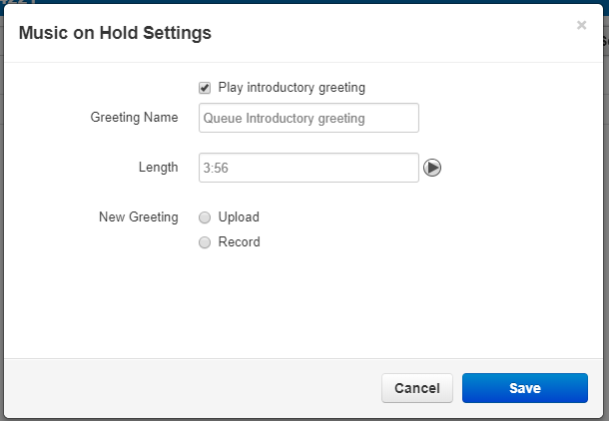
Settings Play introductory greeting
Clicking the Settings button will open the Music on Hold Settings window as seen in figure 5.6.7.2 and will allow you to configure the queue with an Introductory Greeting. A message that will be played to every caller before they are connected with an agent. You can upload an introductory greeting or have the system call you to record one. Name the greeting and click Save.
5.6.7.2

Edit Queue
To the right of the Edit MoH icon is the Edit Queue option as seen in the bottom right of 5.6.6.9. Here you can change any of the configuration options by clicking the name of the queue or the Edit icon.

Delete Queue
To delete a queue click the Delete icon option as seen in the bottom right of 5.6.6.9 and confirm you would like the queue to be deleted.
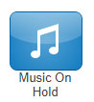

Music on Hold
Music on Hold is what callers hear when their call is placed on hold or waiting in a queue to be answered. Music on Hold can be applied to a specific User, specific Call Queues, or the entire organization.
5.8
Clicking the Music on Hold icon in the Manager Portal navigation icons as seen in figure 5.8 will take you to the Music on Hold for the entire organization as seen in figure 5.8.a. This is the music that is played if the user placing the call on hold has not added any music or if a queue does not have any specific music uploaded.

5.8.a
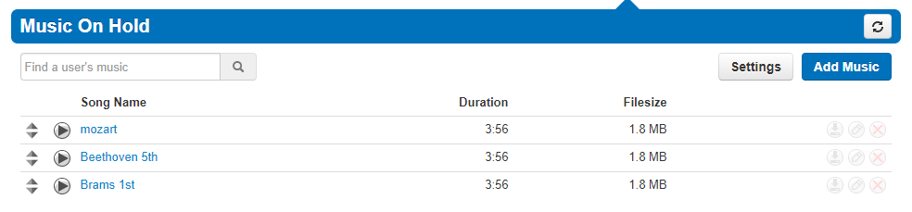

Adding Music on Hold to organization
Add Music button as seen in the righthand corner of figure in 5.8.a will allow you to upload music the entire organization can use. It must be in an .mp3 or .wav file format. Click the Browse button and locate the file on your computer and name the file, then click the Upload button.

Reprioritizing Music on Hold playing order
After the files have been uploaded you can drag and drop the song in the order you would like them to play. Songs are played in a top to bottom order unless the organization has Randomize Music on Hold enabled.

Music on Hold Settings
Clicking the Setting button on the Music on Hold page will open the Music on Hold Settings window as seen in figure 5.7.3 below.
5.7.3
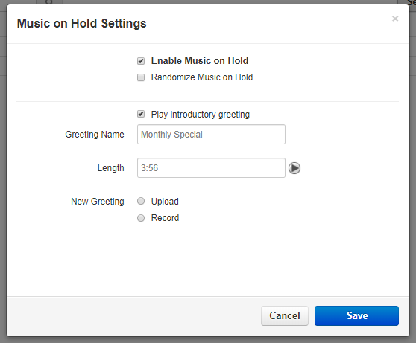

Enable Music on Hold
Clicking this option and adding a check mark will enable Music on Hold. Unchecking it will stop music on hold and callers will just hear ringing.

Randomize Music on Hold
Enabling this option will have the music on hold files play in a random order. If this option is not enable music will played from the top to bottom order the files are listed in.

Play introductory greeting
This option will allow you to play a message to caller entering the queue before they start ringing agents in the queue to be answered.

9.3.3.1 Greeting Name
The Greeting Name is the name of the file being uploaded or recorded as the introductory greeting message.

9.3.3.2 Length
This tells you how long the introductory greeting is.

9.3.3.3 New Greeting
Here you can select the options to upload an introductory greeting or record a message by having the system call you at the destination entered.

Inventory
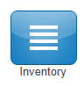
The Inventory icon as seen to the left in figure 5.8 is where you can control where Phone Numbers are routed for voice calls and SMS messages. This is also where you can configure devices to user’s accounts. Clicking the Inventory icon will take you to the Inventory Phone Numbers tab as seen in figure 5.8.a
5.8

Phone Numbers tab
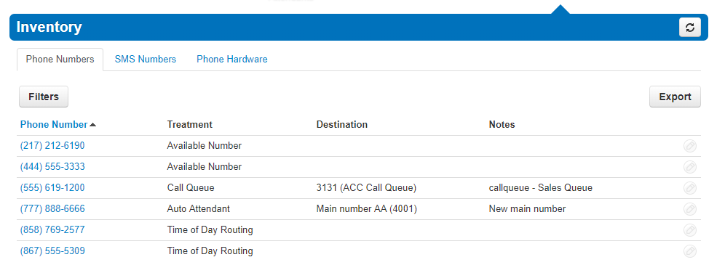
This will take you to the Phone Numbers tab where all the Phone Numbers available to your organization are listed.
5.8.a
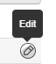
Clicking the Edit icon next to the phone number as seen in figure 5.8.1 will allow you to change control what or application will be handling the call.
5.8.1

Treatment
The treatment drop-down as seen in figure 5.8.1.1 allows you to select what application is going to be handling the call such as a User, Call Queue or Auto Attendant.
Once the Treatment has been selected from the drop-down a User field will appear and allow you to enter the user’s extension as the destination.

5.8.1.1
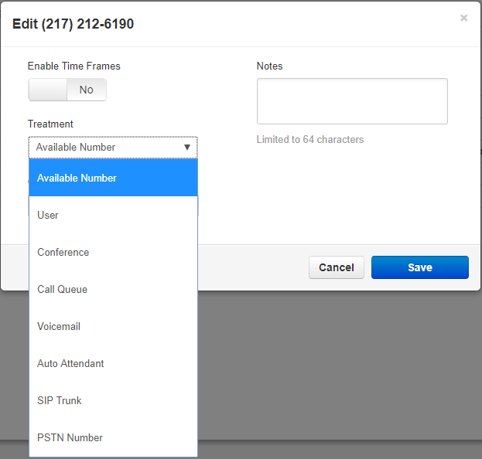

Available Number
This option will keep the number available and will have the phone number appear in the drop down for application options offering for a direct number to be selected.

User
User will allow you to select a user’s extension in the organization to route the calls to.

Conference
Conference will allow you to select a conference bridge to send the call to.

Call Queues
Call Queues will allow you to select a call queue to route the phone number to. It will also let you select the options to:

Announcement for callers:

No announcement
will not play any announcement to the caller being routed to the queue.

Announce number of callers in queue
Will let the caller know how may number of callers in the queue are ahead of them.

Announce average expected wait time
Calculates from the previous call how long it expects the new caller to wait before reaching an agent and provides the caller with an estimate wait time.

Voicemail
Selecting Voicemail as the application will allow you to send the caller to a voicemail box of a user on the system. You will also see the option Enable enhanced voicemail appear. When enabling it will allow the caller to press 0 to be routed out of the voicemail box.

Auto Attendant
When selecting Auto Attendant the Auto Attendant field appears which will allow you to select which Auto Attendant you would like the call routed to.

SIP Trunk
SIP Trunk will allow you to route calls to another SIP trunk if any are configured for your organization.

PSTN Number
This option allows you to route the call to another phone number for the call to be sent to. Helpful if you need to route calls to a 3rd party call center.

Enable Time Frame
The Enable Time Frame Option will allow you to configure the phone number to route the call to different destinations throughout the day based off the time frame selected. After selecting yes as seen in figure 5.8.2 the Select time frame for new rule and Timezone drop downs appear. Here you select a time frame from the drop down then select the application and destination you would like the call routed to.
5.8.2
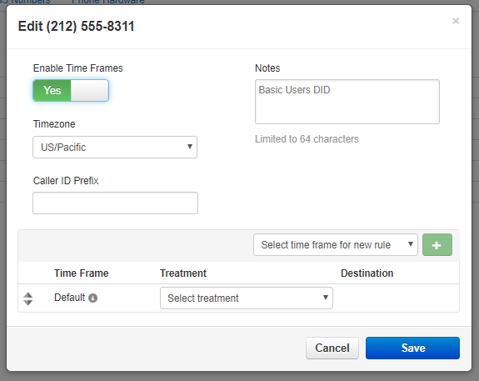

Caller ID Prefix
You can add a prefix to the caller ID before sending it to the destination to help rely information to the person receiving the call such as which telephone number the call came in over.

Notes
Notes allow you to add a description to the telephone number that can help you identify what this number is used for in the future.

Filter
The Filter button as seen in figure 5.8.a allows you to search for Phone Numbers based on the Phone Number, Treatment, Destination, or Status. Clicking the filter button will display the Phone Number Filters window as seen in figure 5.8.5.

5.8.5
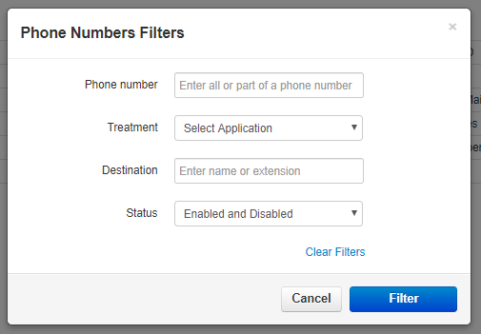

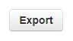
Export
You can also Export your Phone Numbers into a CSV file by clicking the Export button as seen in figure 5.8.6 and saving the file to your computer.

5.8.6

SMS Numbers tab
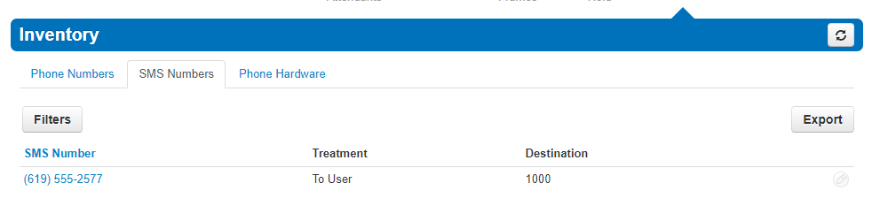
The SMS Numbers tab as seen in figure 5.8.7 will allow you to point numbers provisioned to allow SMS messages to a User’s extension number on the system.
8.5.7
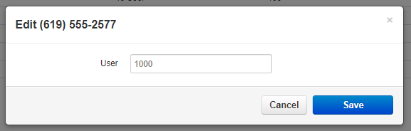
Clicking the edit to the right of the number will bring up the Edit window as seen in figure 5.8.7.a and allow you to select the destination you would like to route the SMS messages to.
5.8.7.a

Phone Hardware tab
The Phone Hardware tab as seen in figure 5.8.8 below, will list all the devices configured on your organization.
5.8.8
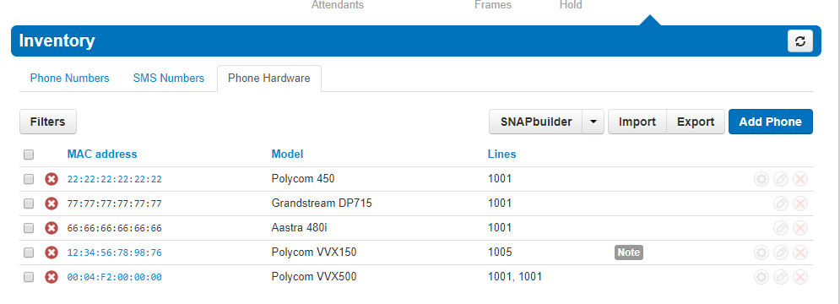

Add Phone
You can add phones to your organization and point them to Users by clicking the Add Phone button as seen in figure 5.8.8 above. When you click on the Add phone button the Add Phone window will appear as seen in figure 5.8.9 below.

5.8.9
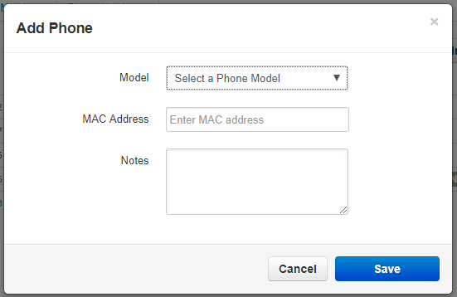
Selecting the Model of the device we want to add. Then entering the MAC Address of the device. The user field will appear and allow you select a user you would like to associate the device with.

The Notes field allows us to add additional information we may find helpful.

Advanced tab
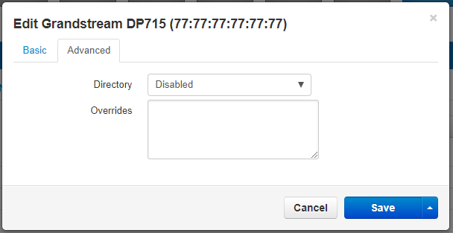
The Advanced tab appears after selecting the device as seen in figure 5.8.10.
5.8.10

Directory
The directory drop down as seen in figure 5.8.10 allows for you to configure if the device display by first name or last name. If you would like to use the company directory or your favorite contacts displayed on the device directory.
After the device has been created you can click the Edit icon and The Advanced tab will appear allowing you to configure the device with a Directory.

Overrides
Override field as seen in figure 5.8.10 allows you to add device manufacture overrides to the device configuration file to enable or manipulate features the device manufacturer offers.

Export
The Export button on the Phone Hardware tab allows you to Export your list of devices into a .csv file. You can also Import a .csv file to bulk create extensions.

SNAPbuilder
5.8.12
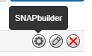
The SNAPbuilder icon as seen in figure 5.8.12 will take you to the SNAPbuilder as seen in figure 5.8.12.a and allows you to configure the device line keys with:
- Line Appearance
- Shared Line Appearance
- User BLF
- Call Park
- Speed Dial
- Queue Toggle
- Time Frame Toggle
5.8.12.a
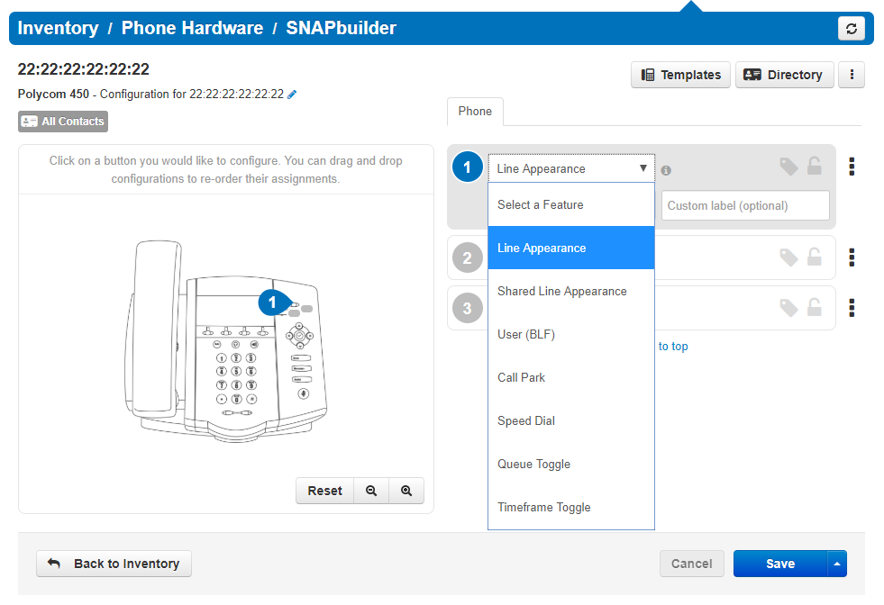

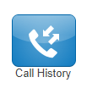
Call History
The Call History icon as seen to the left in figure 5.9 takes you to your Call History which is a list of all the calls made to and from your organization as seen in figure 5.9.a.
5.9

5.9.a
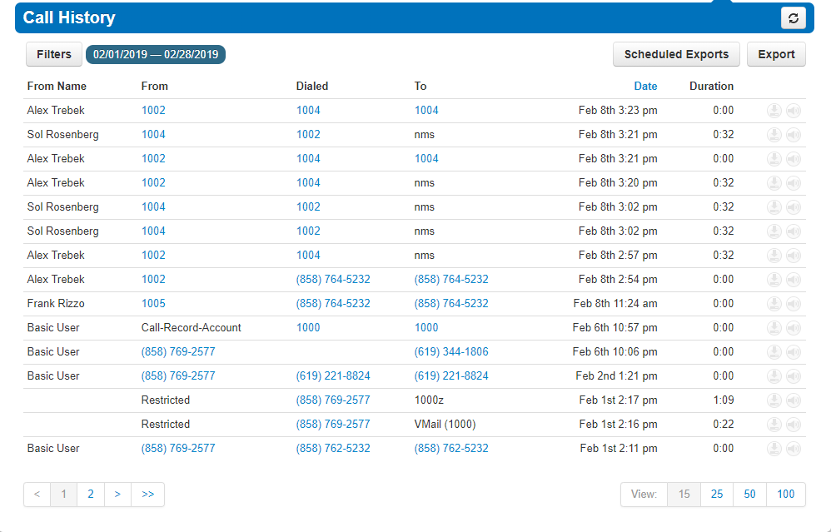

Filter
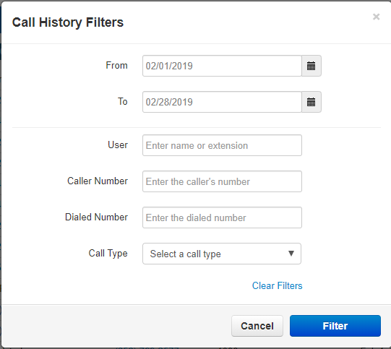
The Filter button as seen in figure 5.9.a will open the Call History Filters window as seen in figure 5.9.1 and allow you to filter for calls from a specific:
5.9.1
- User
- Caller Number
- Dialed Number
- Call Type
So only those calls that met the Filter criteria are displayed.

Export Call History
To export the call history into a csv file click the Export button as seen in figure 5.9.1.

You can also configure a scheduled export to be set by clicking the Scheduled Exports button. After clicking the button the Schedule New Export window as seen in figure 5.9.2 will display.
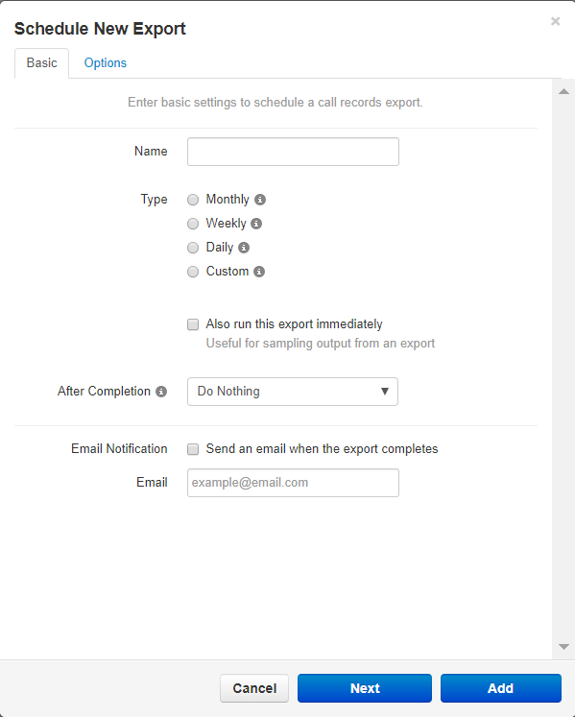
On the Schedule New Export page, you will see the field to name the scheduled export.
5.9.2
Then the Type of export:

Monthly
Will let you select the Day of the month.

Weekly
Will let you select the Day of the Week and Time of Day to Start

Daily
Which will allow you to select the time you want the report started.

Custom
Will allow you to select the period of time you want to capture. The time you would like the export to start. The Time Zone you want the export call times to be in. Then allow you to configure if you would like the export to repeat and at what interval to repeat.

Allow run this export immediately
Run this export immediately will send an export as soon as the scheduled export has been created.

Email Notification
Will send the email address entered an email letting them know the schedule export has run.

Options tab
The options tab will allow you to filter for just a specific extension. Select if we want the export to include Inbound Calls, Outbound Calls, Headers, or filter for Off-net Calls Only. You can select the format of the csv file.

After the Schedule export has been created you can edit any of the options by clicking the edit icon. Download the scheduled export.

